|  |  |
| --- | --- |
| CA 2 – Web and UI Design | **Aline da Silva /X00135202**  Higher Diploma in Computing Science |

# Web and UI Design

# Continuous Assessment 2 – value 30%

# Out Date: Thursday 30th March 2017

# Submission Date: Wednesday 3rd May 2017 - 6pm

# Description

You are required to work in groups to plan, design, develop and later evaluate your website. The website you create should look like a real working site, examples include:

* Sports club website
* A charity website
* Small business website
* A music website (if you are in a band etc.)
* A website relating to a personal interest or hobby (No fan websites – e.g. premier league football club related sites, etc. are not acceptable)

1. The website should be developed using client side technologies (i.e. run in browser) covered in our class (HTML 5, CSS, and JavaScript). You are not required to include server side functionality.
2. The site should be standards compliant (see W3.org) and follow best practice for accessibility and compatibility across all browsers and platforms.
3. You should ensure that you have copyright for any content, including images, included in your site.

Summary

### Group selection and website title

* Maximum of two group members.
* Website title and group members should be added to the CA project document on Moodle

### Analysis / Plan (15%)

* Define your target audience. 3
* Identify user requirements and goals. 3
* Survey Analyses 4-6
* Examine the features of similar websites. 7-8

### Design (20%)

* Site structure and organisation 10
* Page layout 11-20
* Navigation 21-22
* Storyboard 23-38

### Development (50%)(separated folder)

* Build a prototype website using HTML5 and CSS3.
* You can use Twitter Bootstrap if you wish

### Evaluate and Update Prototype (15%)

* Site Testing (errors, browser issues, cross platform). 39
* Usability testing (Accessibility, Navigation, Readability). 41
* Review website after testing and update the prototype. 42

### Analysis / Plan (15%)

* Define your target audience.

The computer shop is located in a Walkinstown where most part of the population is 45 + because of this the website will be targeting his other half of customers the international business. Most part of the international business is based in UK, and previously this business was done through Ebay but now working with Ebay and Paypall is getting very hard because of this The Computer shop owner decided to direct all the purchases to his own website.

* Identify user requirements and goals.

Requirements:

The website should be as easy as possible for the customers to find the product that they are looking for. Example the home page is designed for the customer to find the products by category that is why we have 6 pictures representing main products and services: desktops, laptops, ipads & tablets, phones, parts and services. Also we are just adding the bestselling product from each category.

Goal:

Sell products to customers abroad and generate money.

### Survey Analysis

1. What is your gender?

female

male

2. How old are you?

3. On a typical day, about how many hours do you spend  on your device?

0-1

2-3

4-5

6-7

More than 7

4. Which of the following electronic devices do you use? (Please select all that apply.)

Desktop Computer

Laptop Computer

Tablet (e.g. iPad, Samsung Galaxy)

Android Phone

I don’t own any of these electronic devices

5. What devices brands do you have at home?

Dell

Apple

HP

Assus

none

Other (please specify)

6. How much would you pay for a tablet/Ipad?

100-200

200-300

300-400

400+

Other (please specify)

7. How much would pay for a phone?

100-200

200-300

300-400

400+

Other (please specify)

8. Do you prefer to make purchases online or in-person, assuming there is no difference in quality or price?

Prefer online

Prefer in-person

No preference

9. How often do you buy devices of technology?

when it breaks

every time of an update

every year

Other (please specify)

10. How easy was it to find what you were looking for on our website?

Extremely easy

Very easy

Somewhat easy

Not so easy

Not at all easy



Analyses of the Survey:

* As you can see above women spend more time in a device of technology than men;
* 3 of 4 people spend most part of the time in an android phone;
* There are a variety of brands for phone devices those;
* Women would pay more for a tablet and a phone rather than men;
* Women and Men shop more online rather than in person;
* Women and Men found the website very easy to navigate on the website.

### Examine the features of similar websites.

The carrousel from Harvey Norman comparing from the The computer shop website: 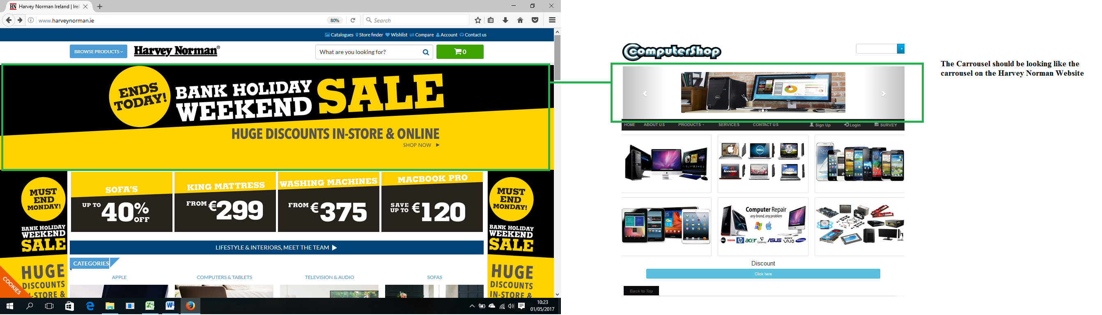

The features & design from the Dell website comparing with the computer shop website:

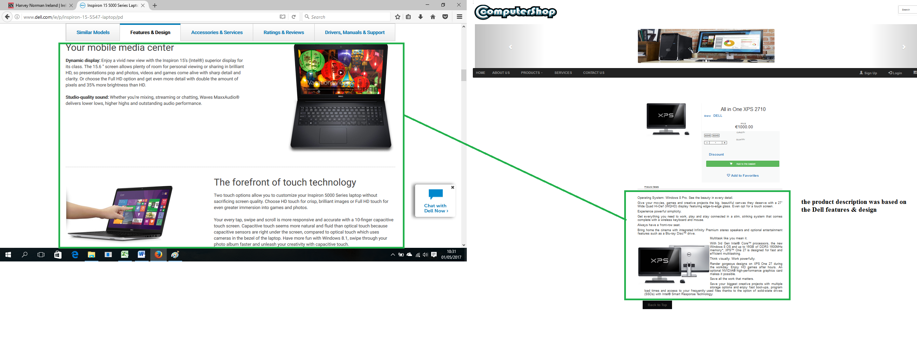

### Design (20%)

### Site structure and organisationOrganisation:

### Page layout

**Home:**

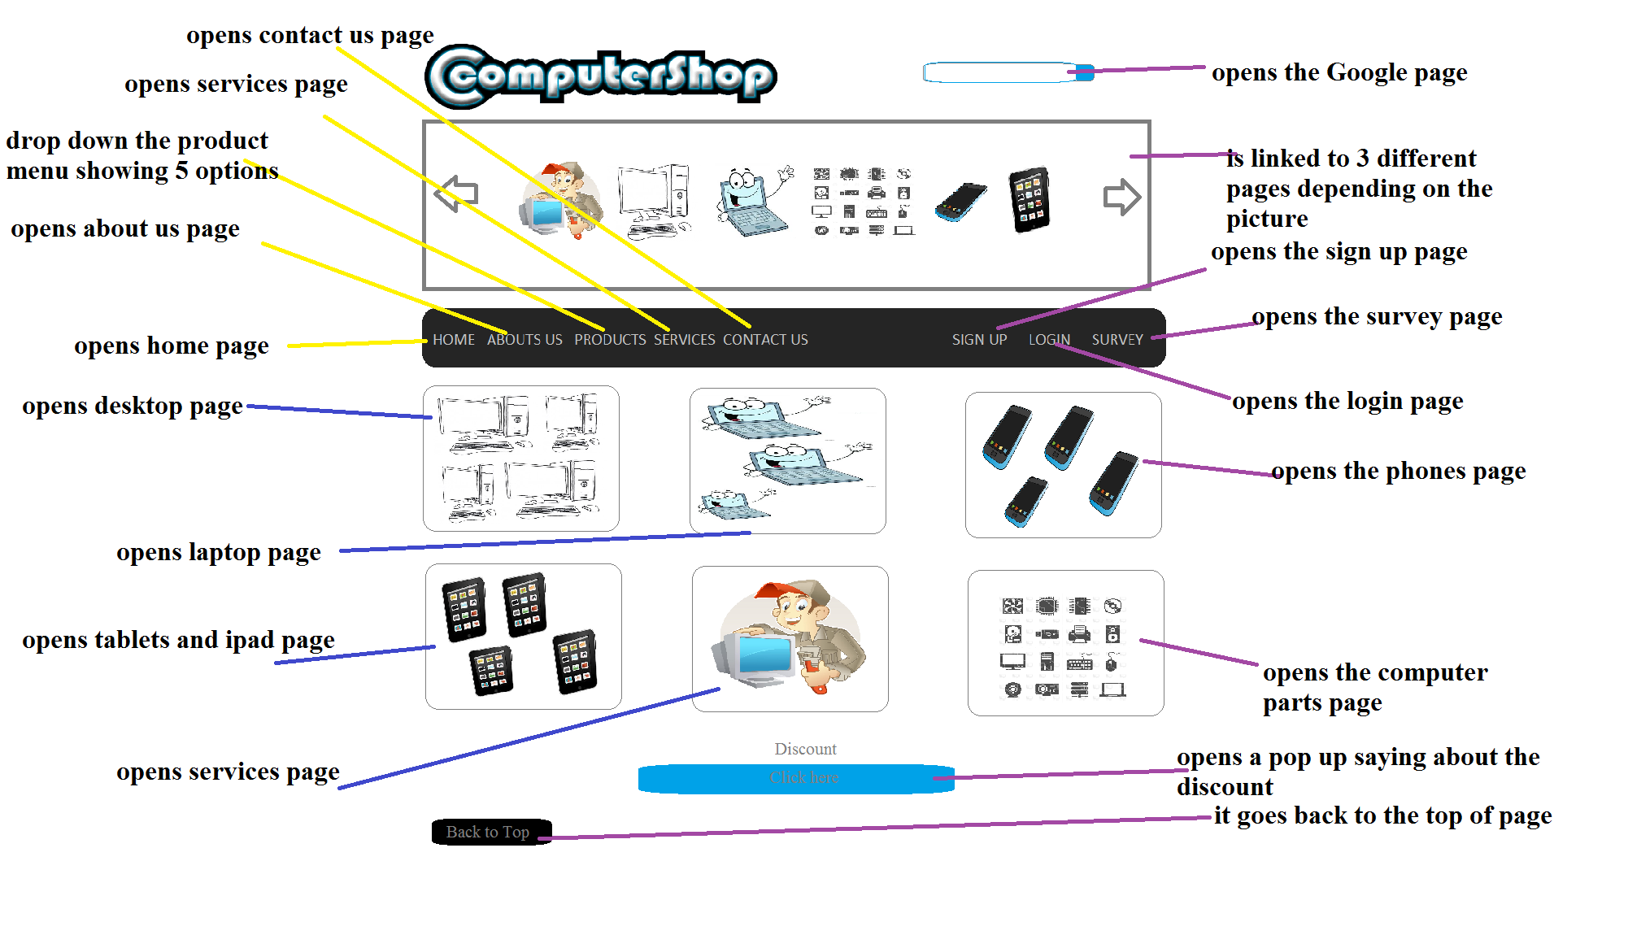

**About us:**

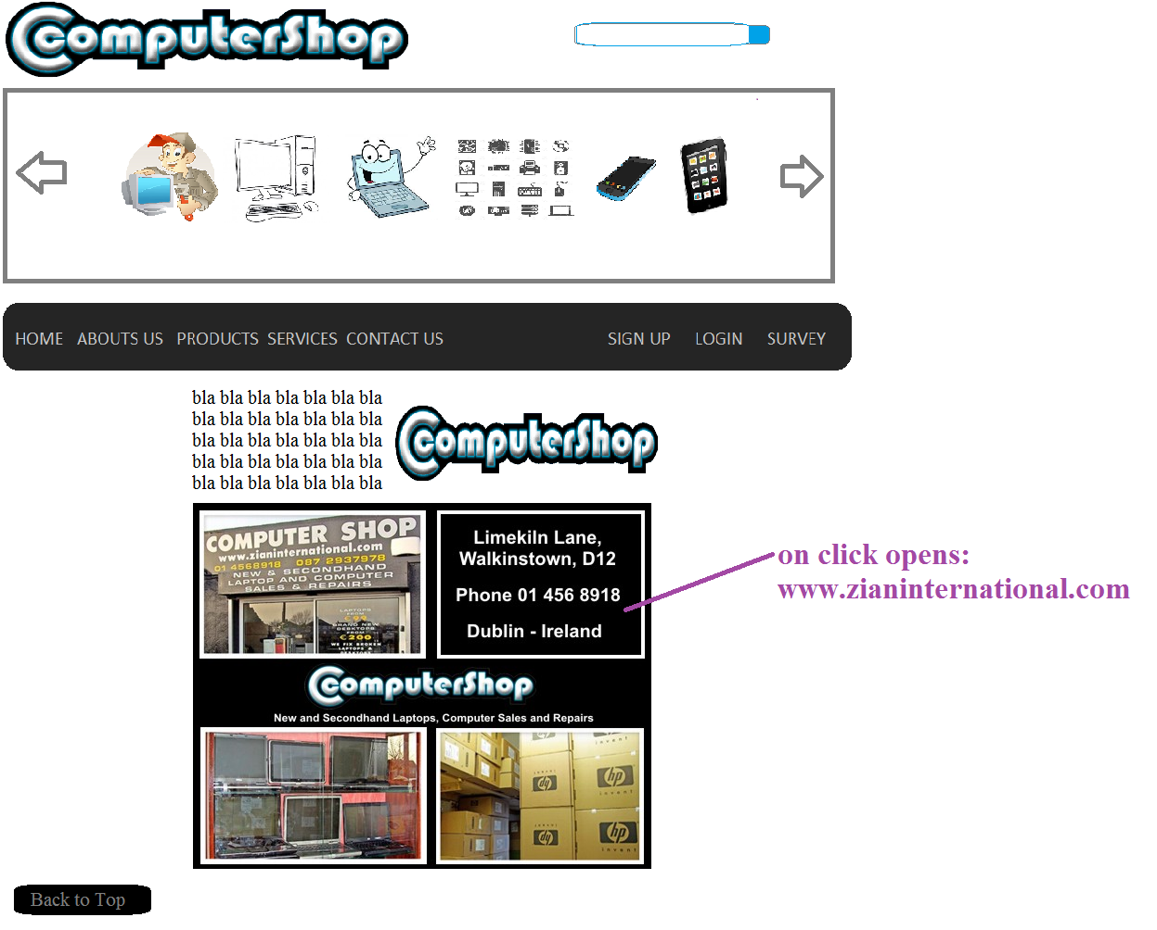

**Products: Desktop:**

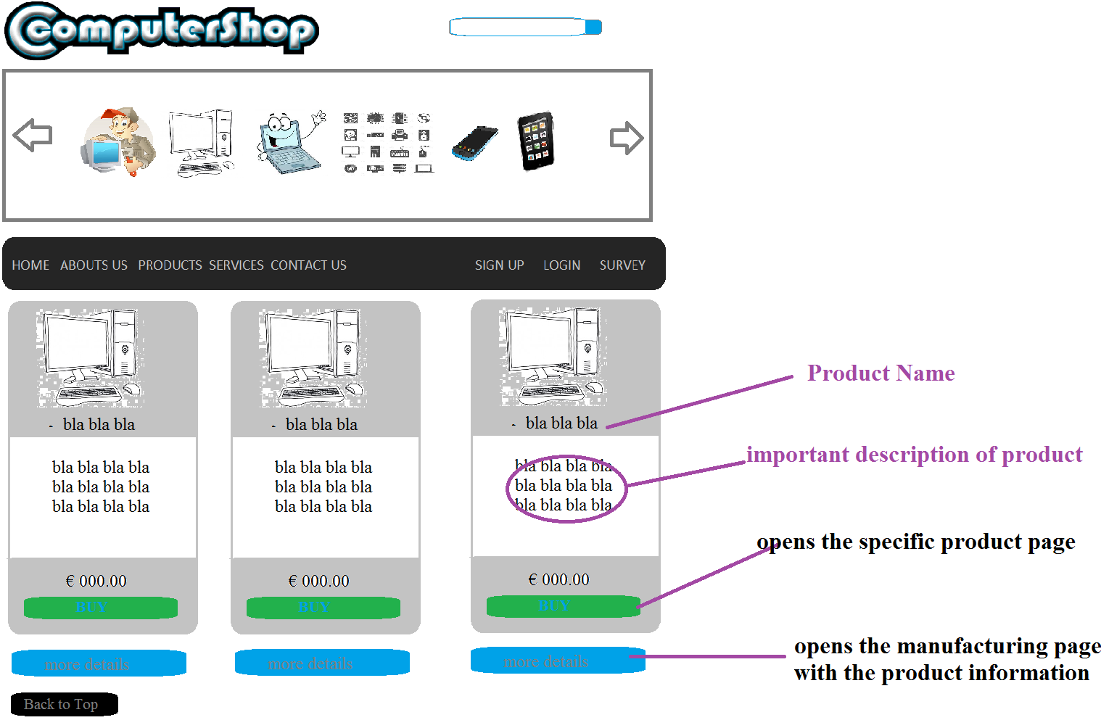

**Products: Laptops:**

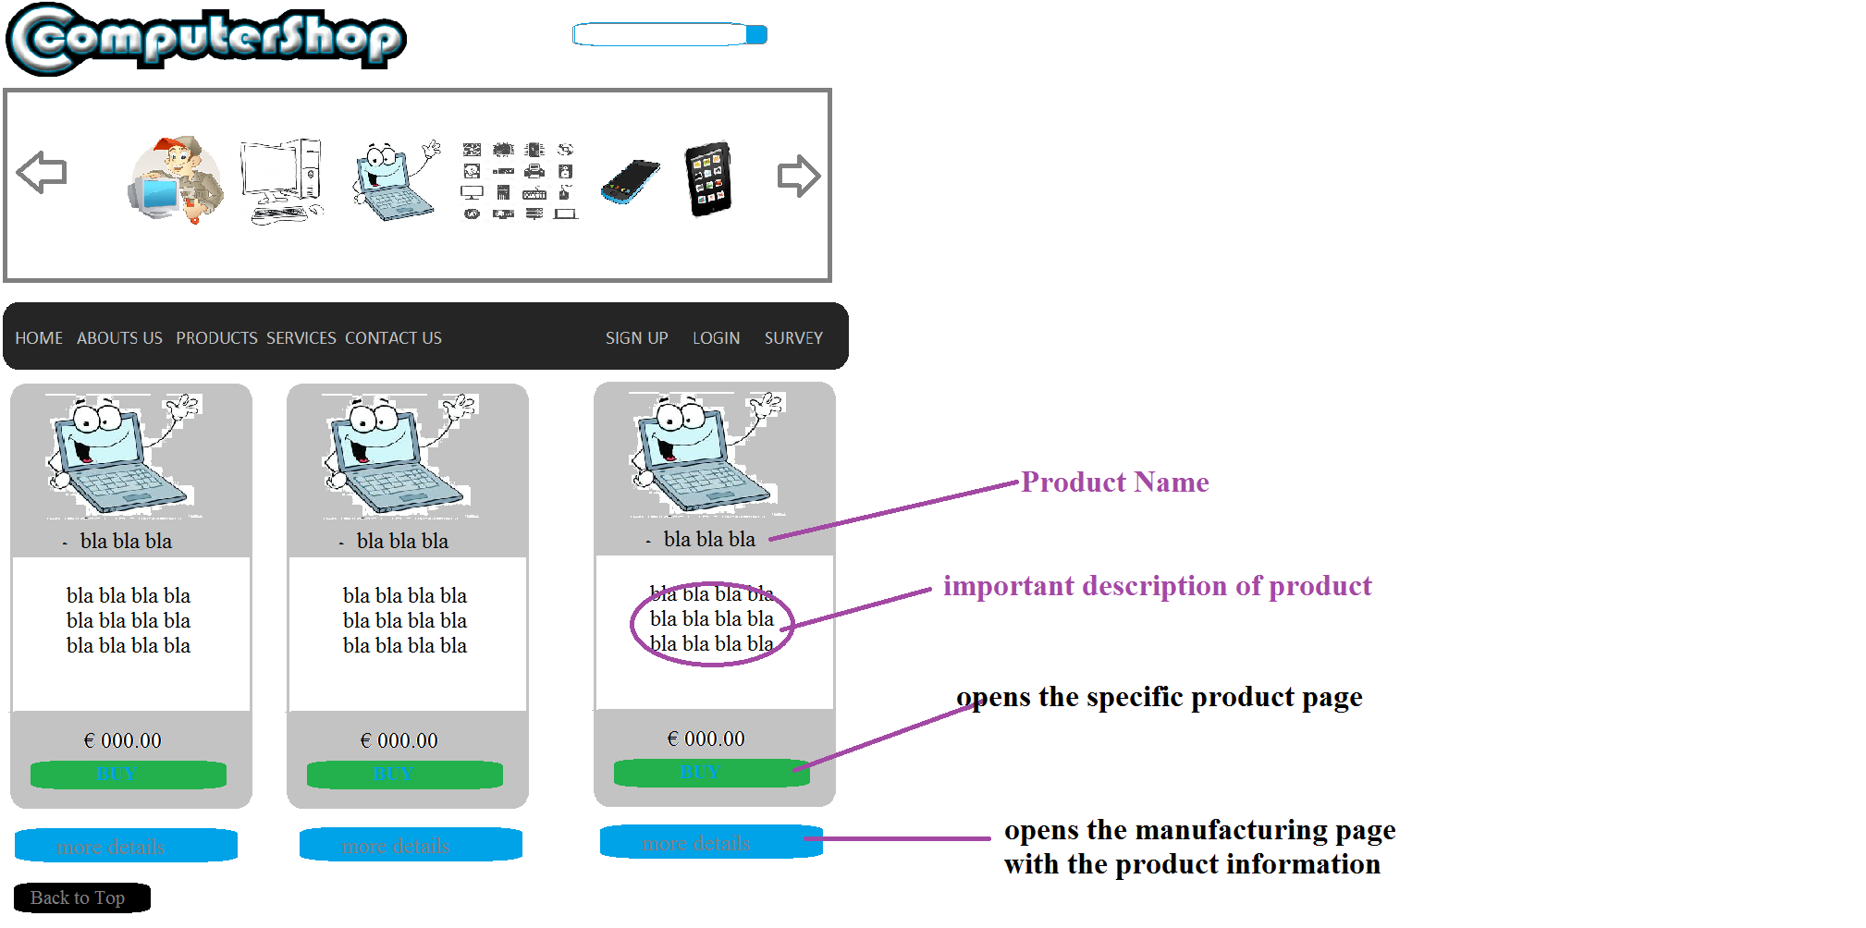

**Products: Ipad & Tablets:**

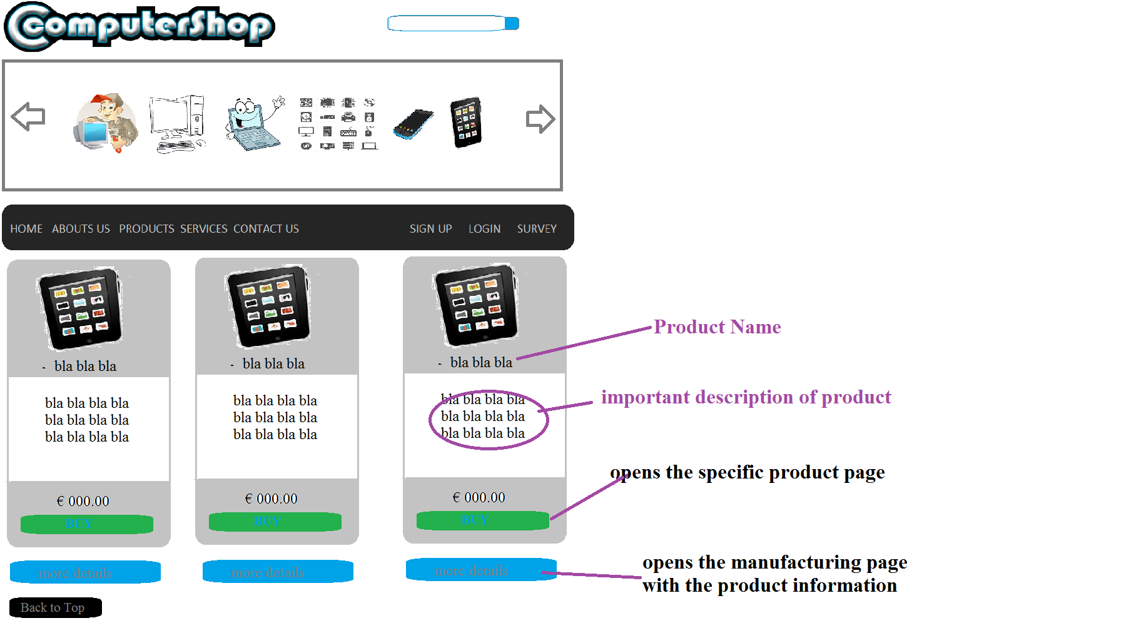

**Products: Phones**

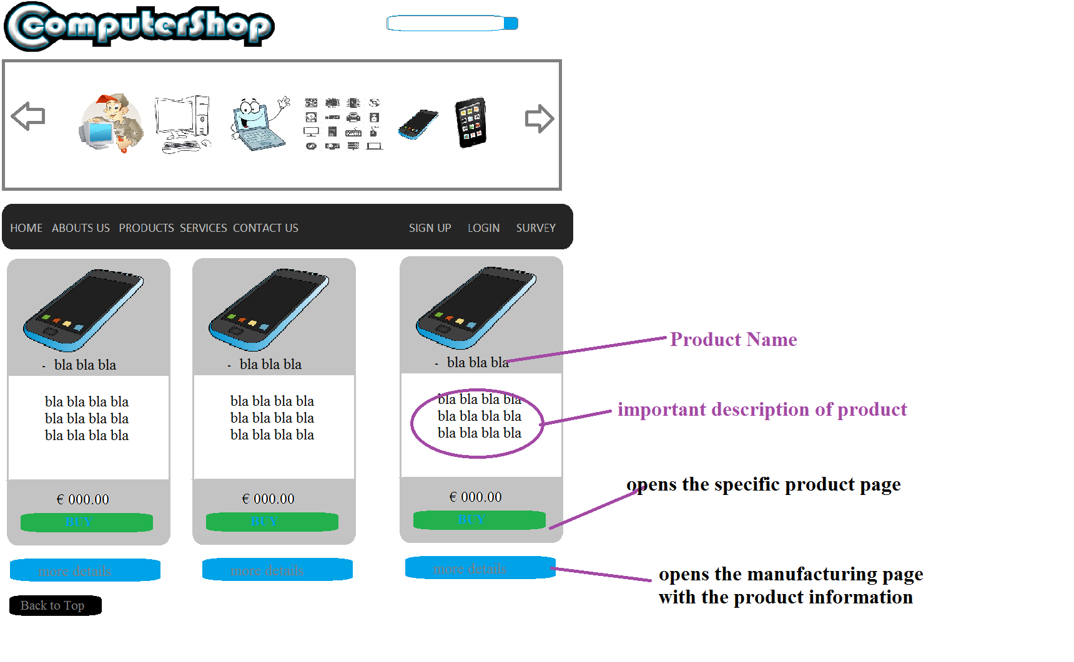

**Products: Parts**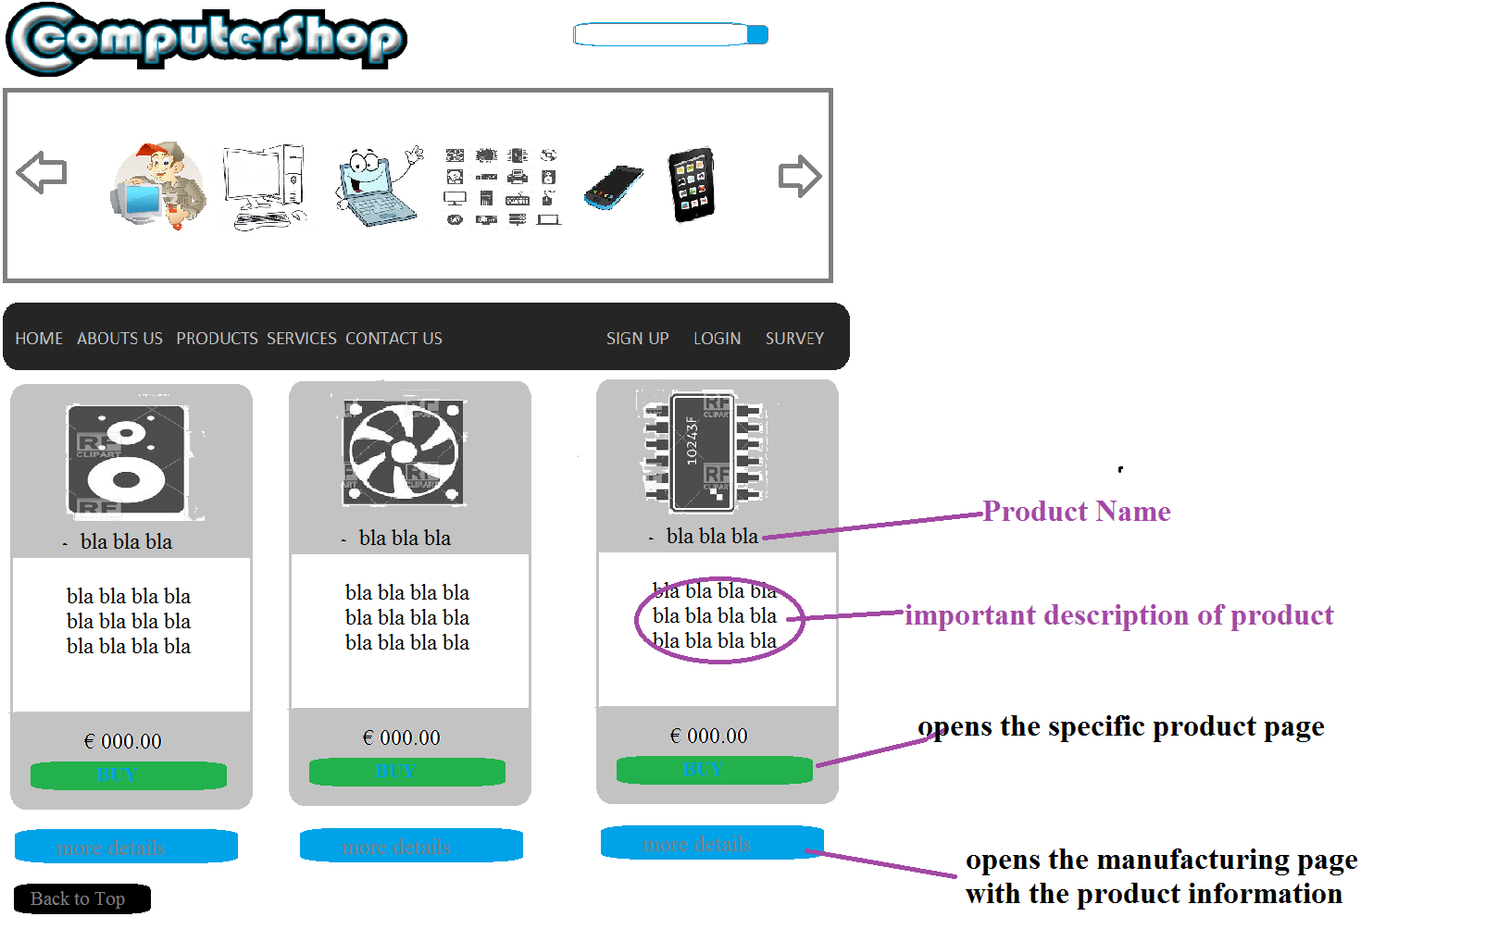

**Services**

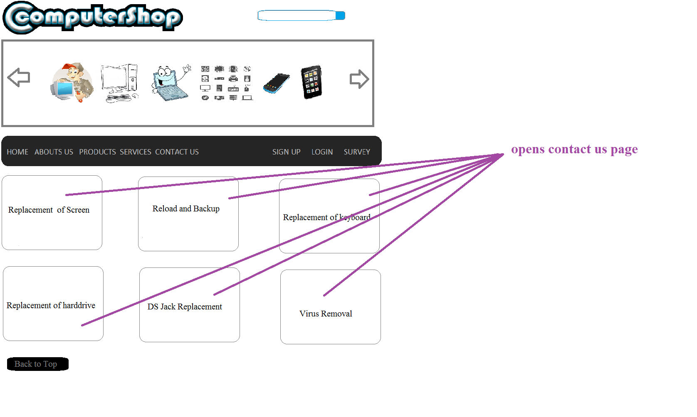

**Contactus:**

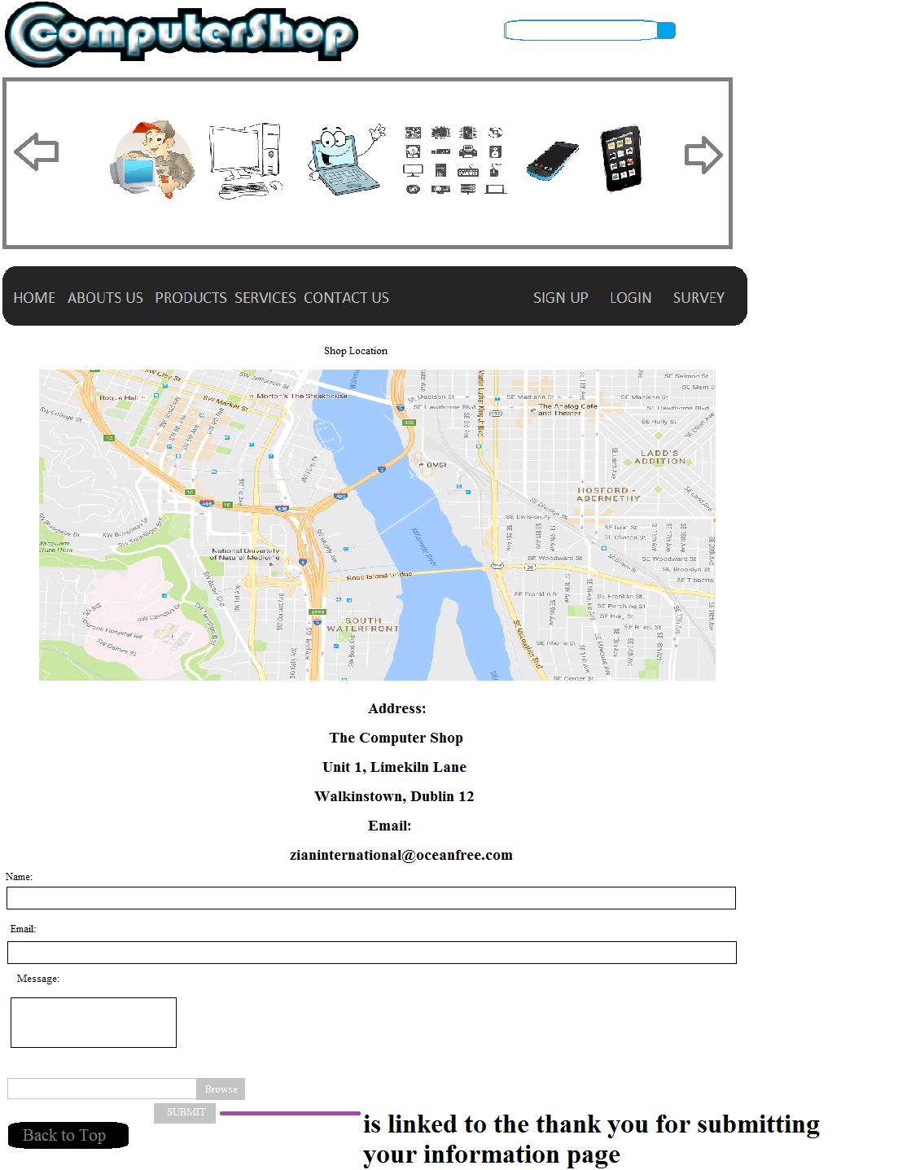

**Sign up:**

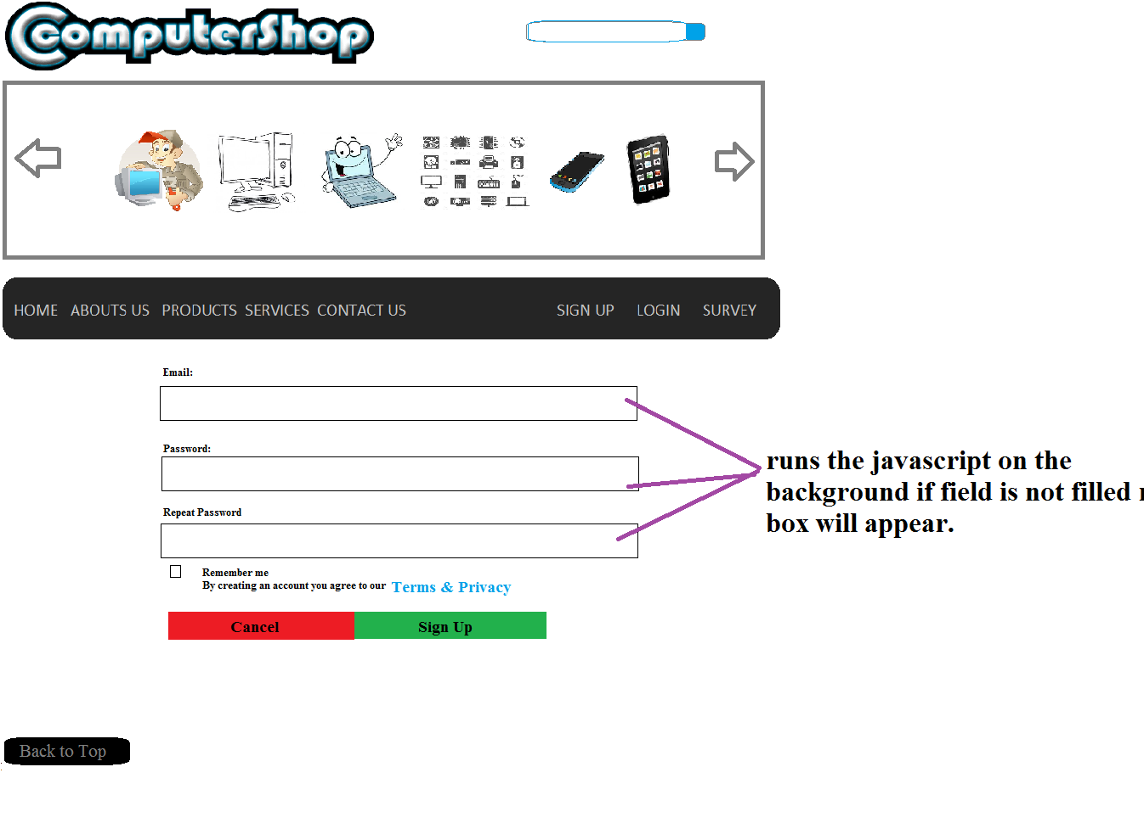

**Login:**

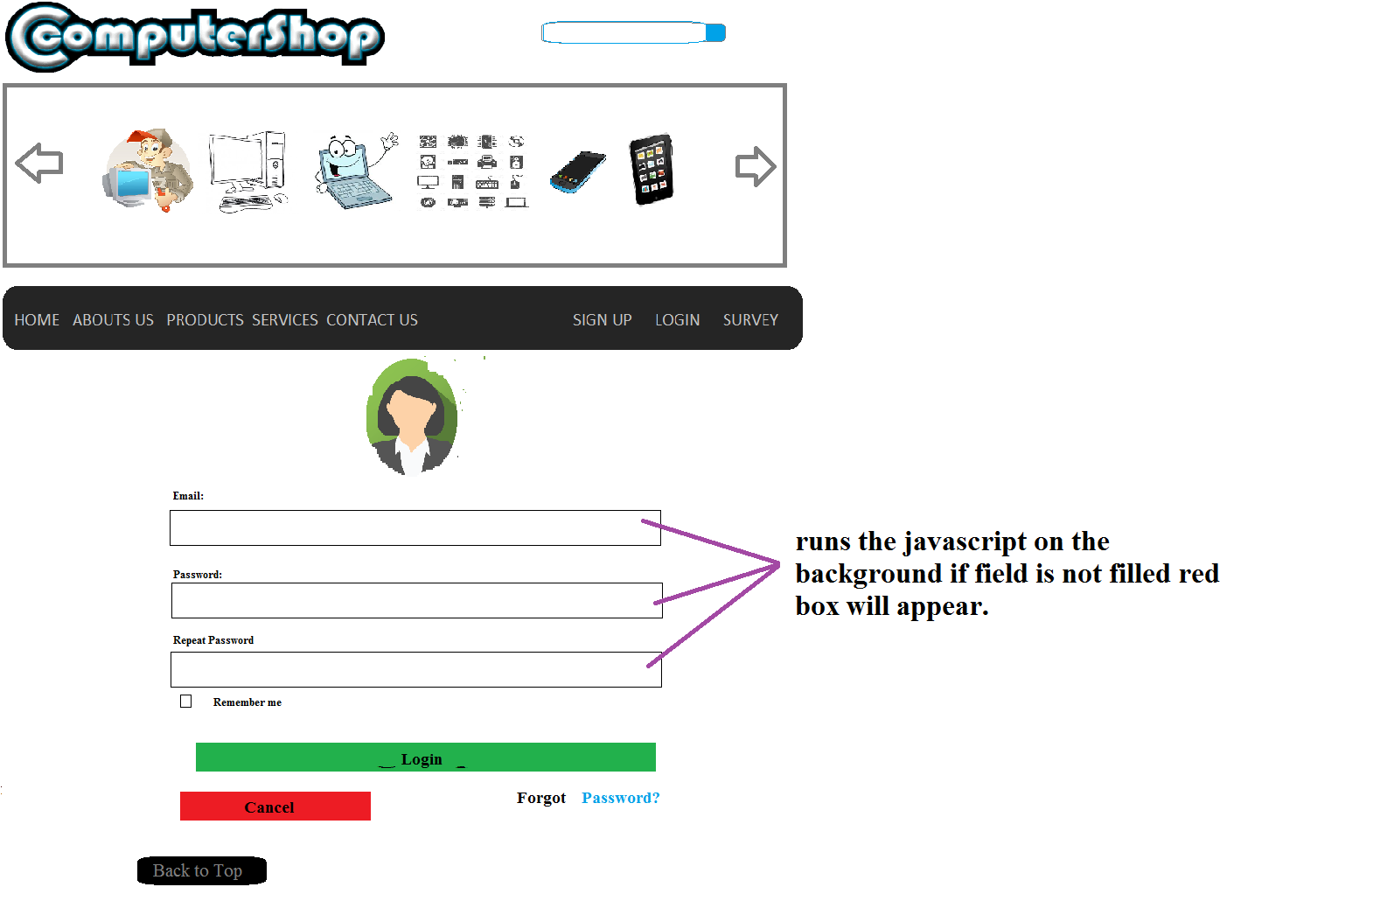

**Survey:**

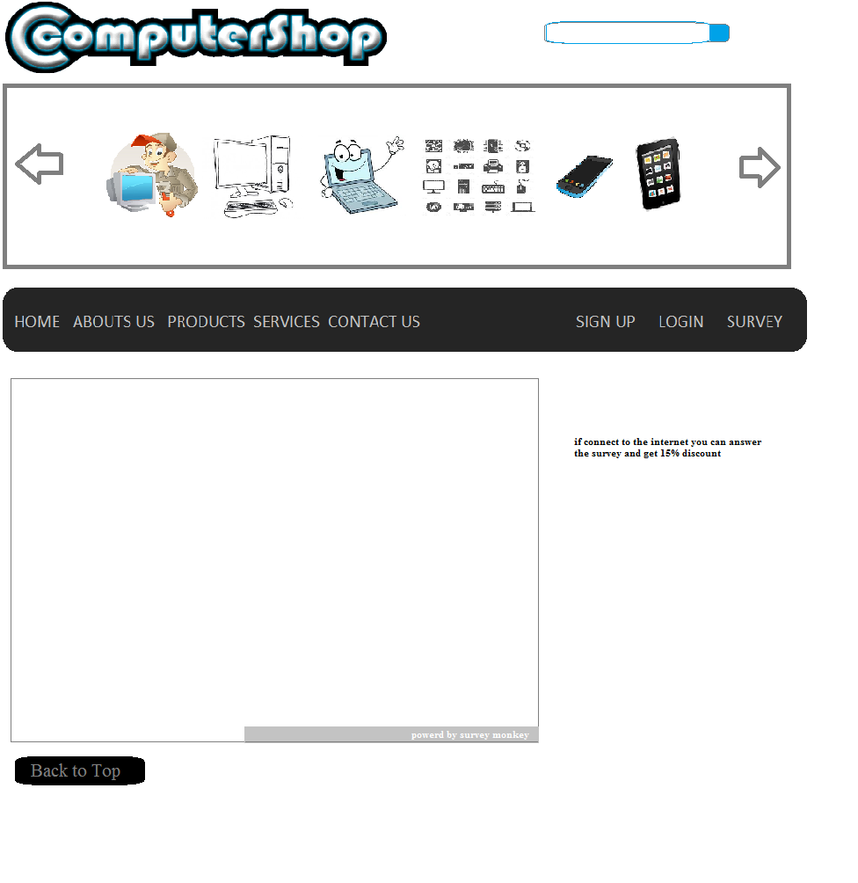

**Product Page:** 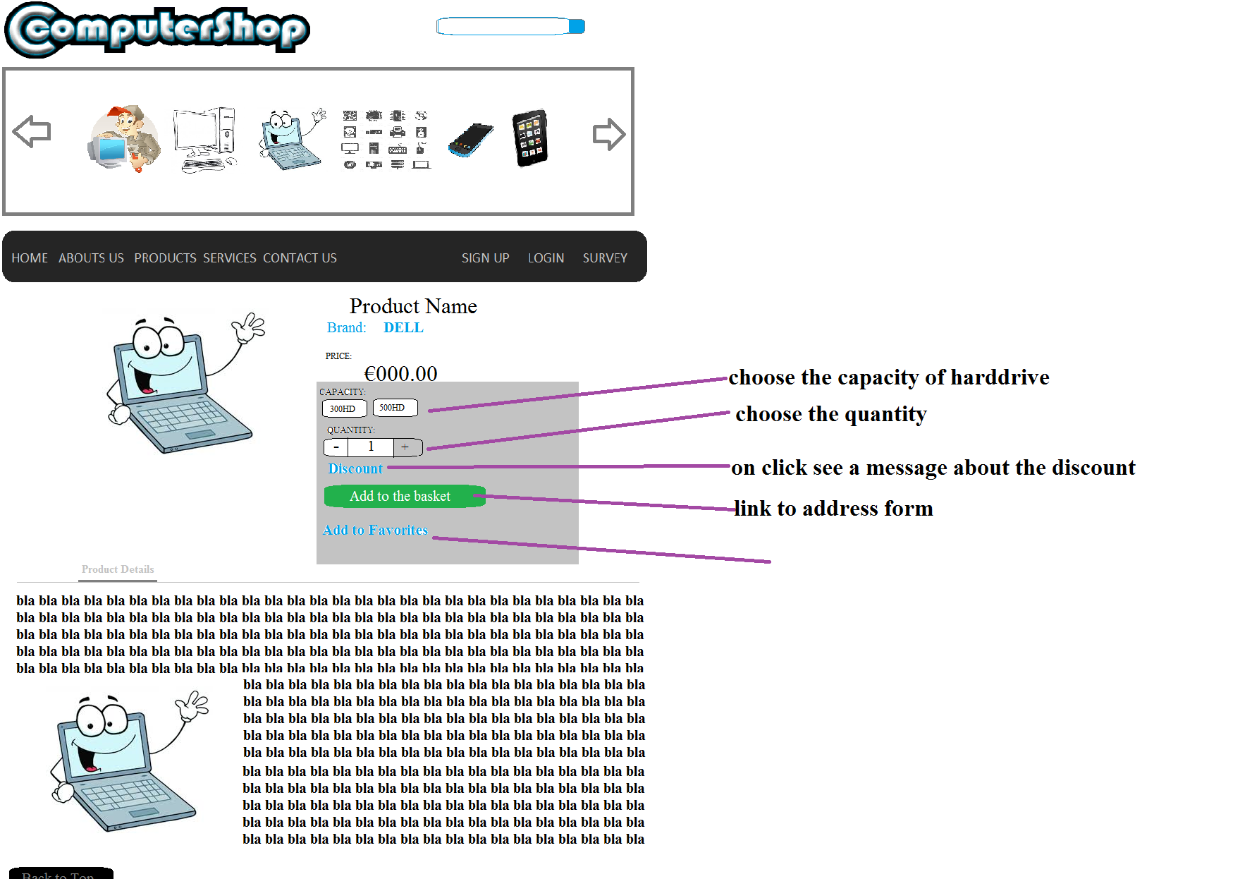

**Address form:**

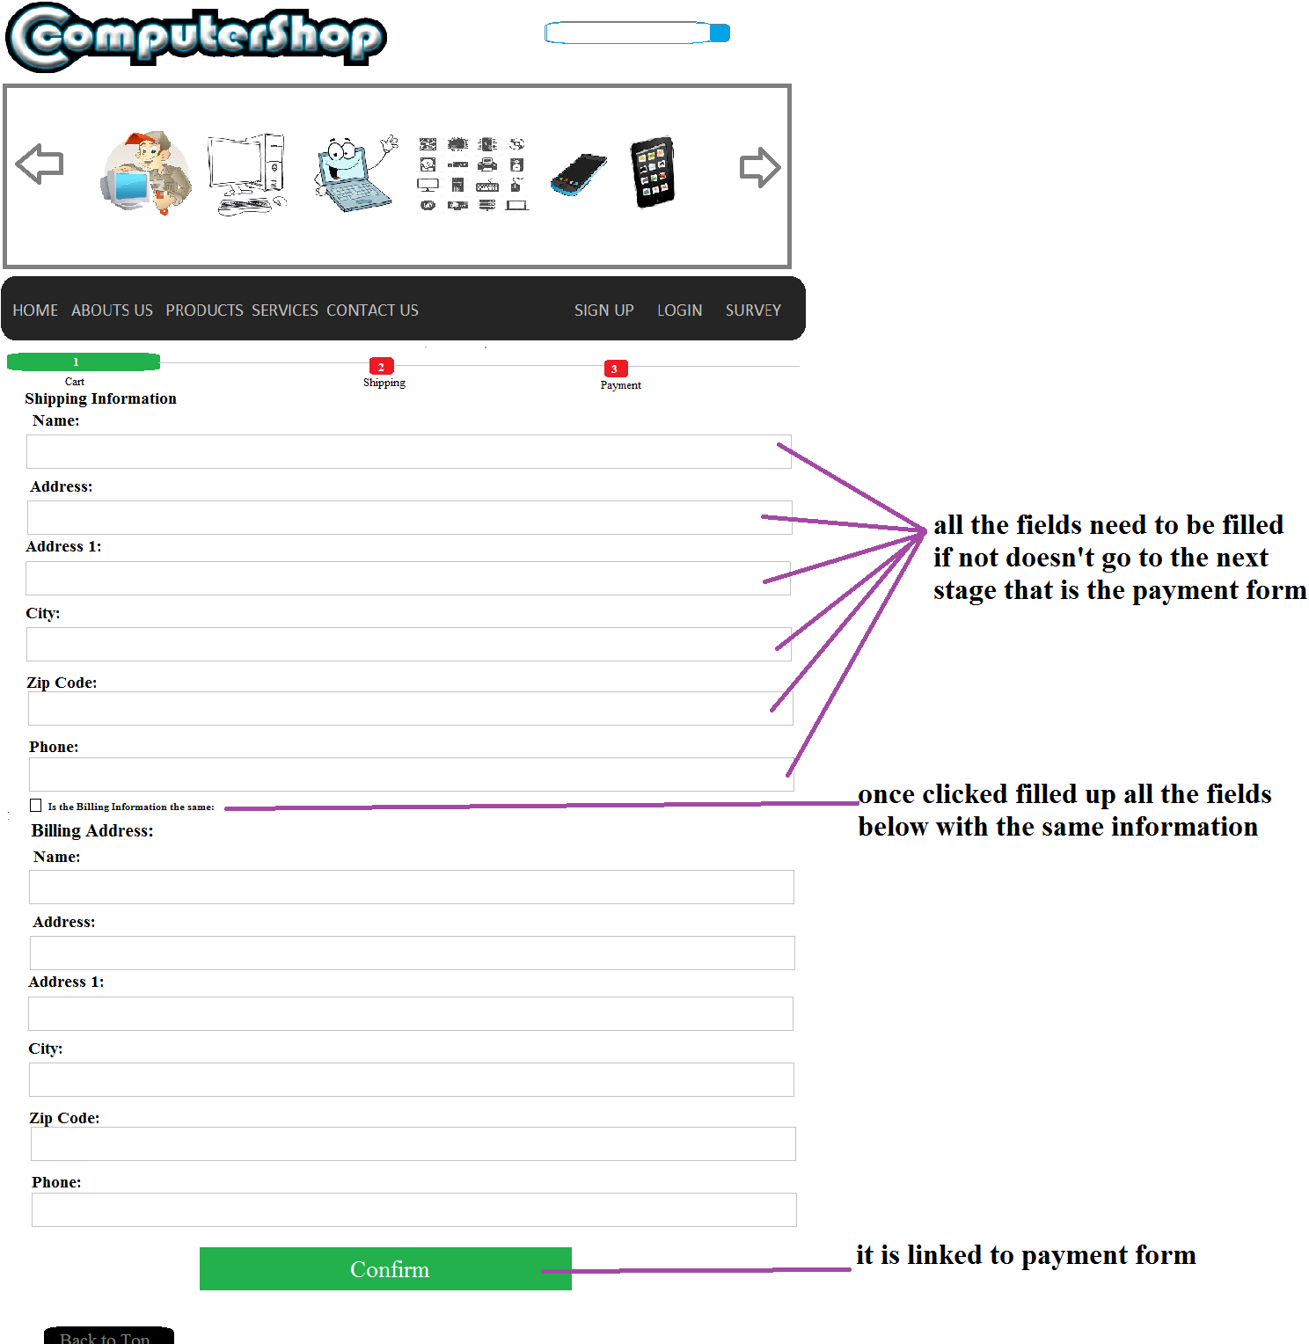

**Payment Form:**

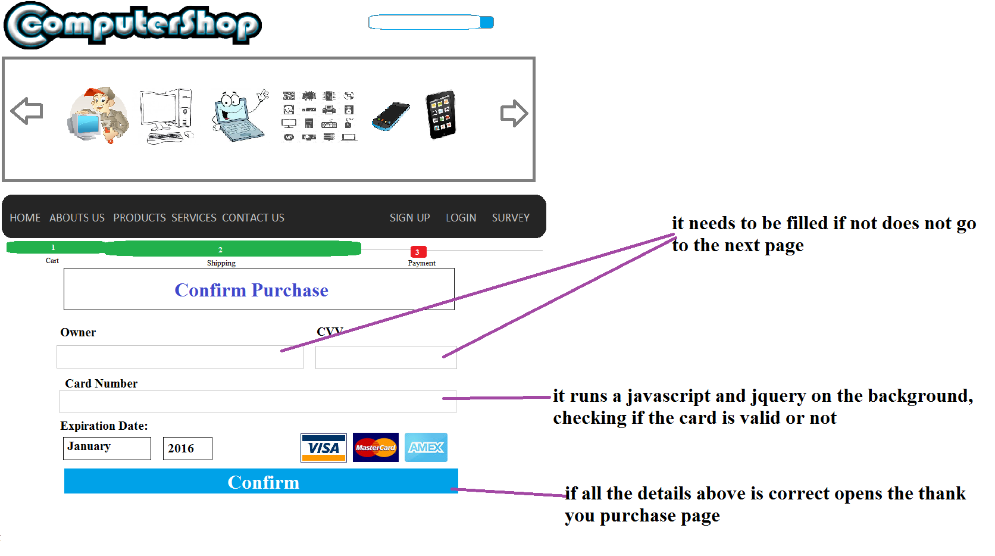

**Thank you for the purchase:**

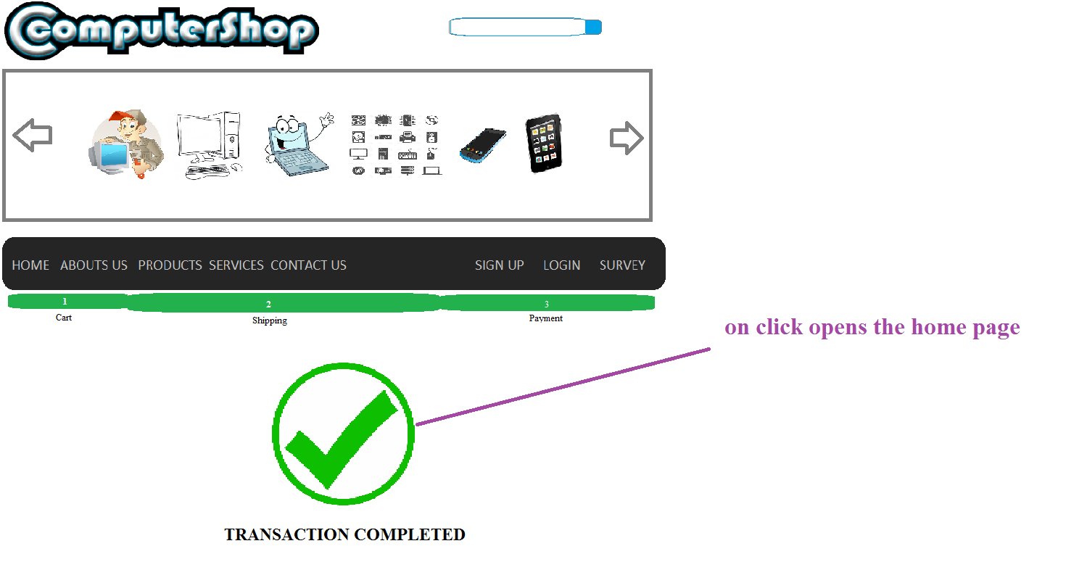

### \\COMPHOME\homedir$\X00135202\Desktop\CA2 hope -6\doc\navigator.pngNavigator:

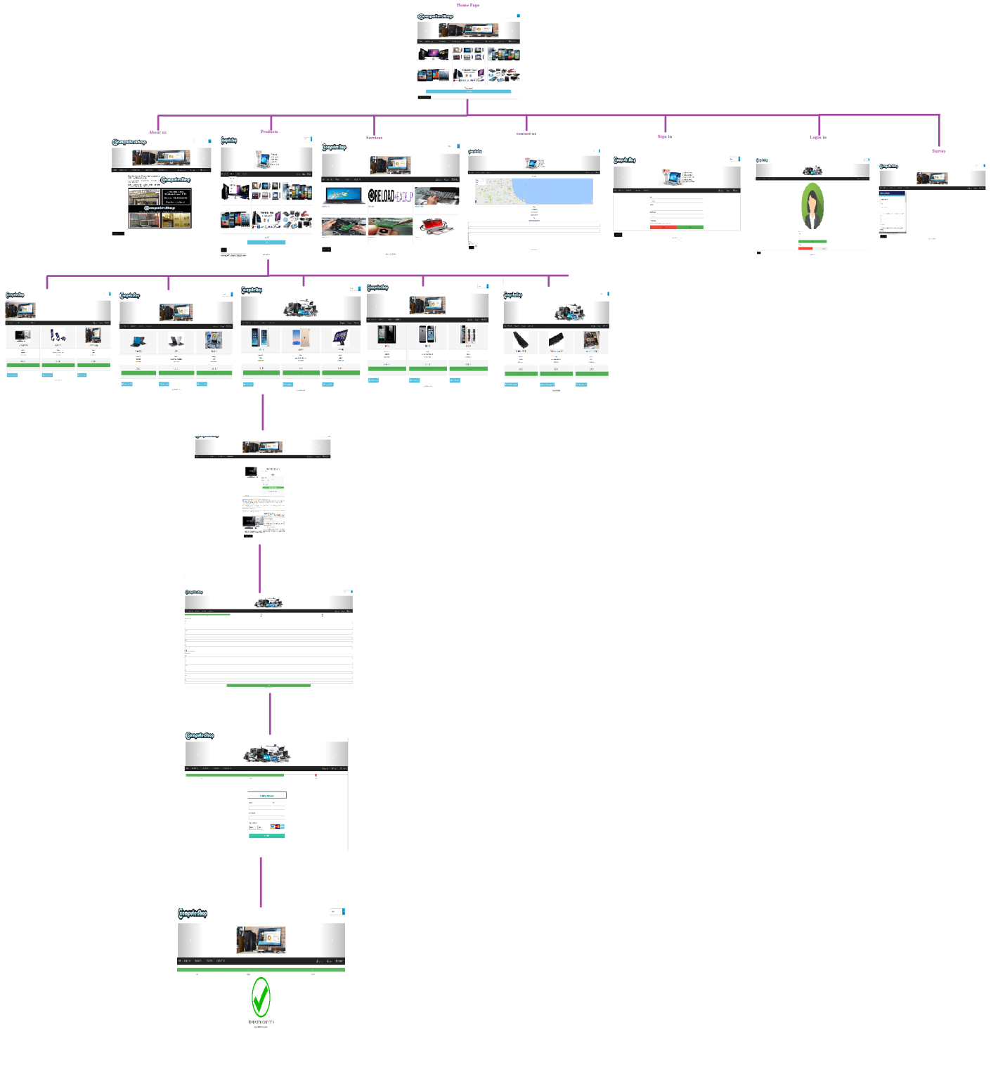

### Storyboard:

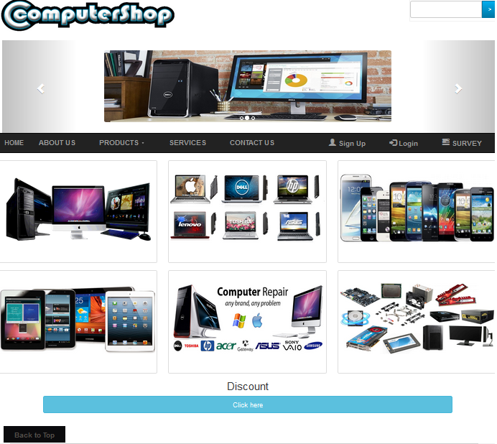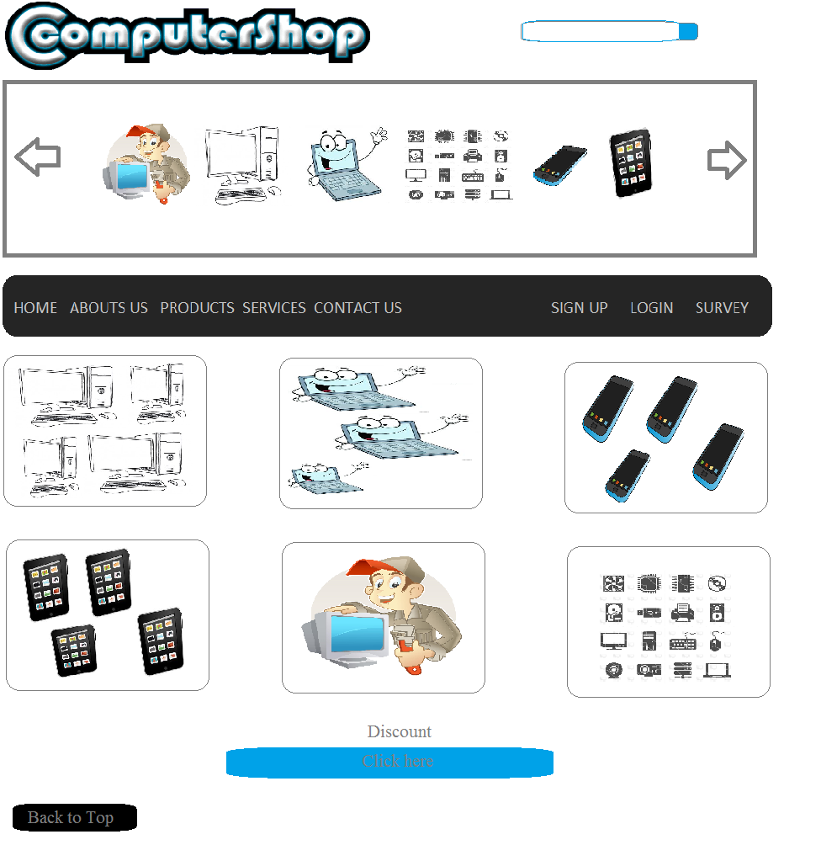**StoryBoard Home: Actual Website Home:**

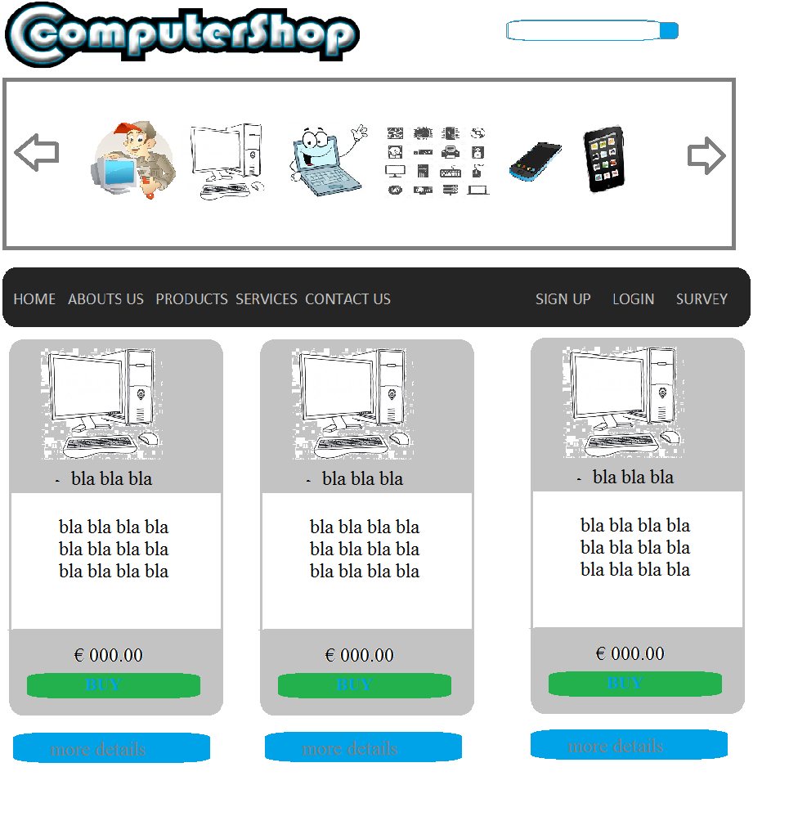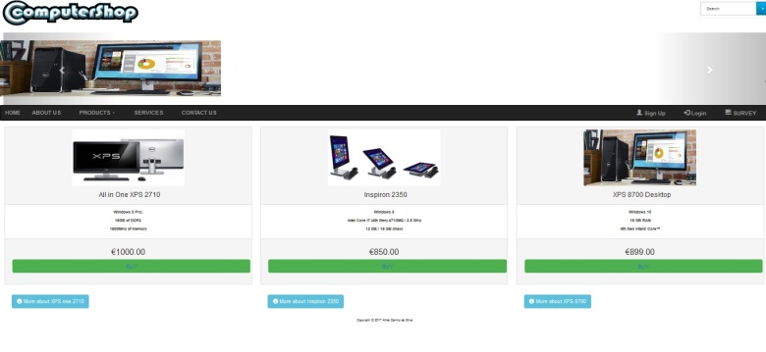**Storyboard: Desktop Actual Website: Desktop**

**Storyboard: Laptop Actual Website: Laptop**

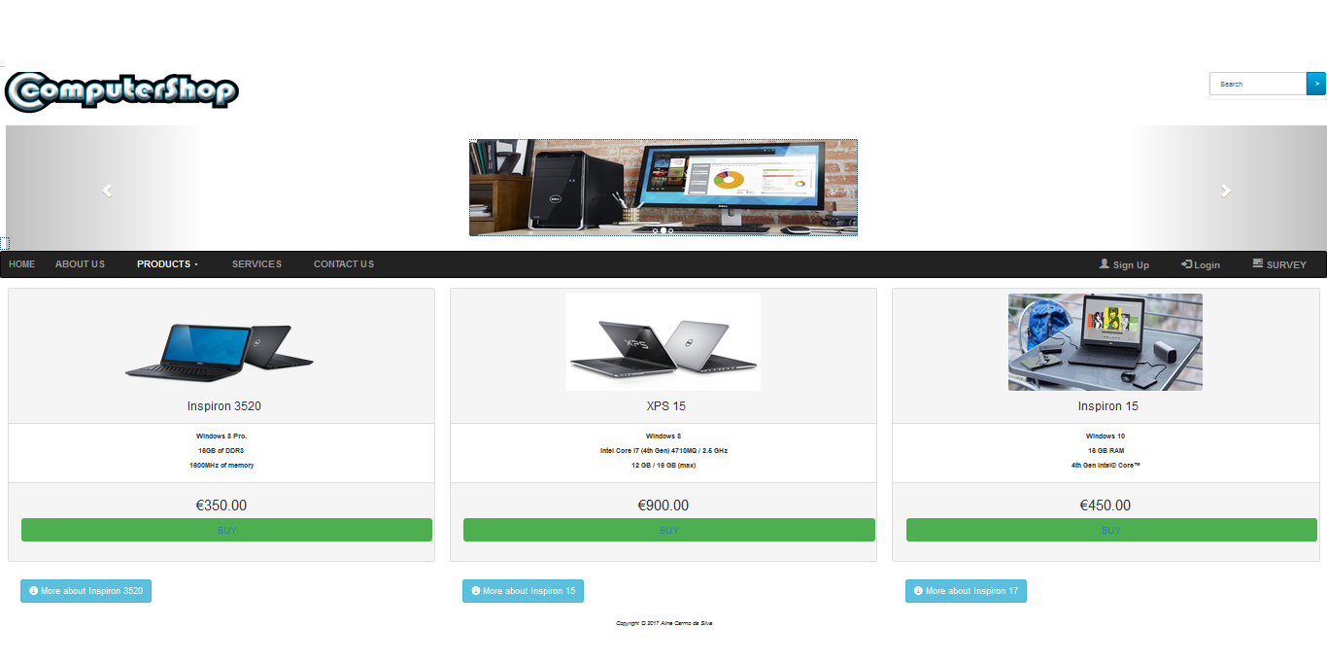

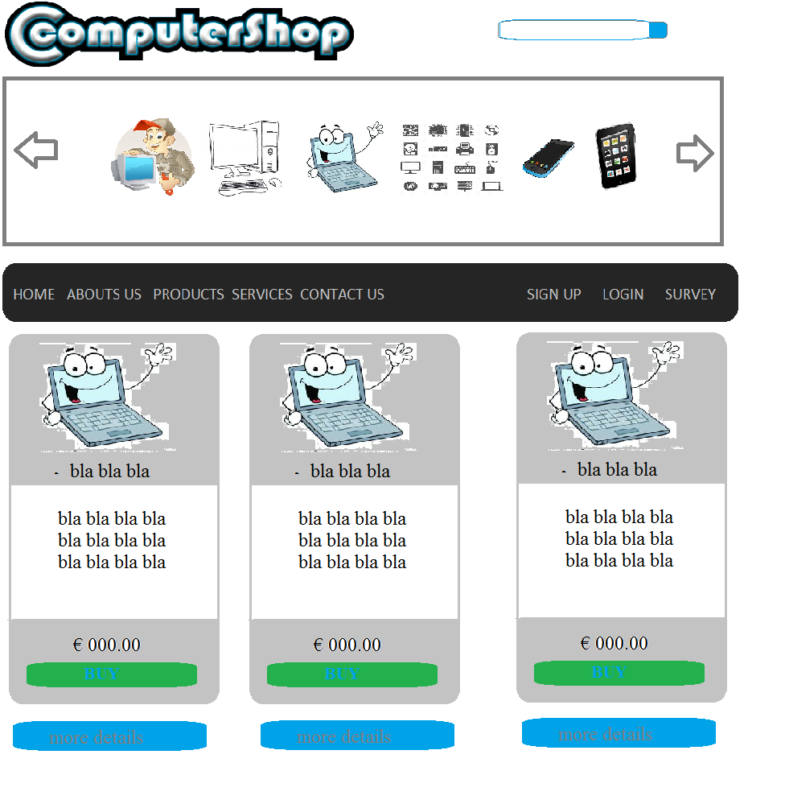

**Storyboard: Ipads & Tablets Actual Website: Ipads & Tablets**

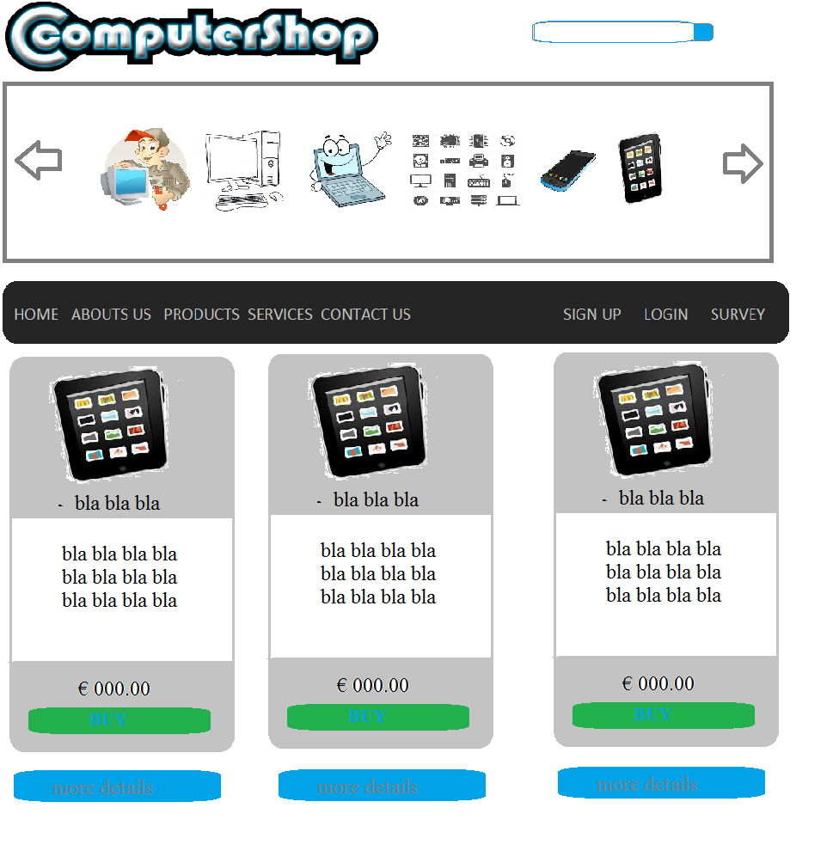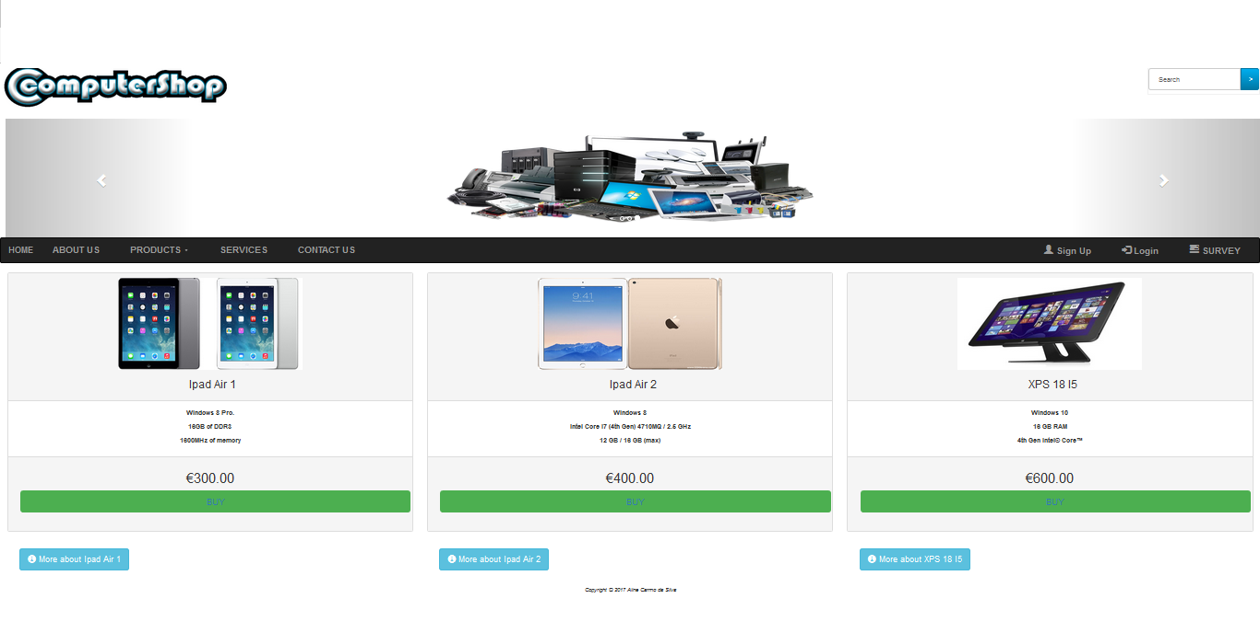

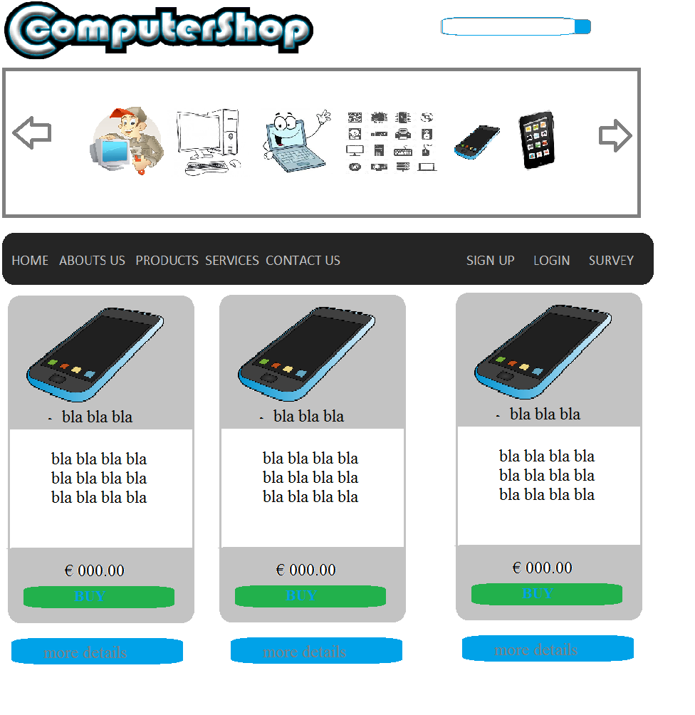**Storyboard: Phones Actual Website: Phones**

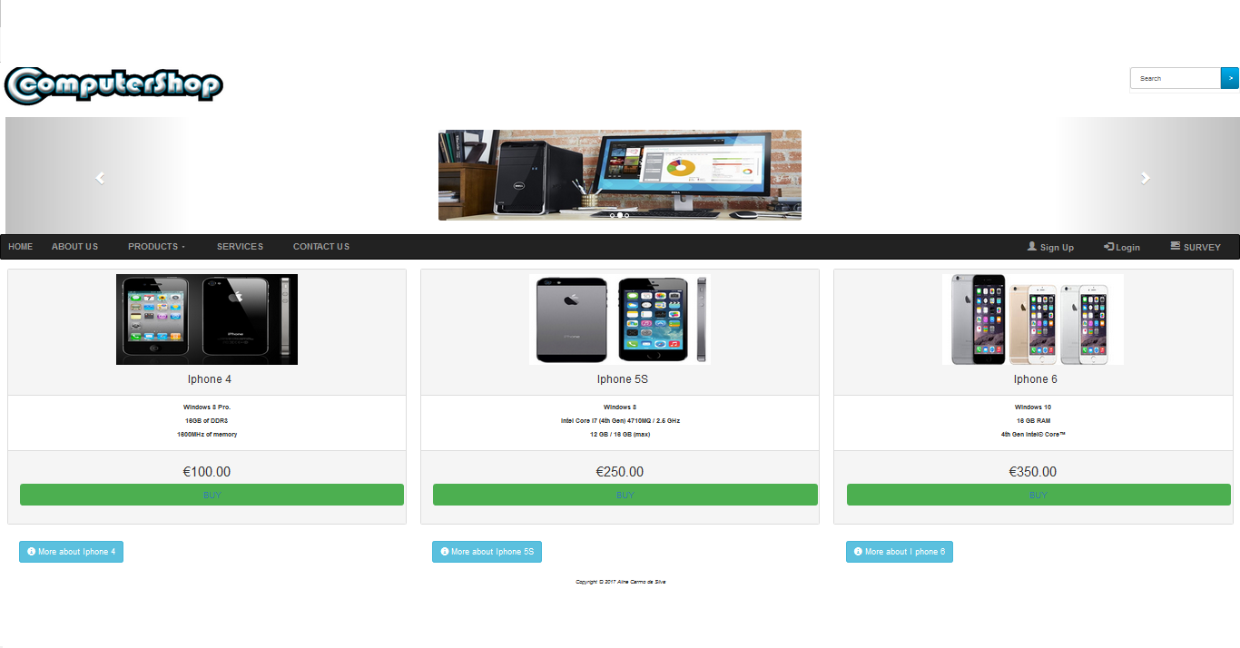

**Storyboard: Parts Actual Website: Parts**

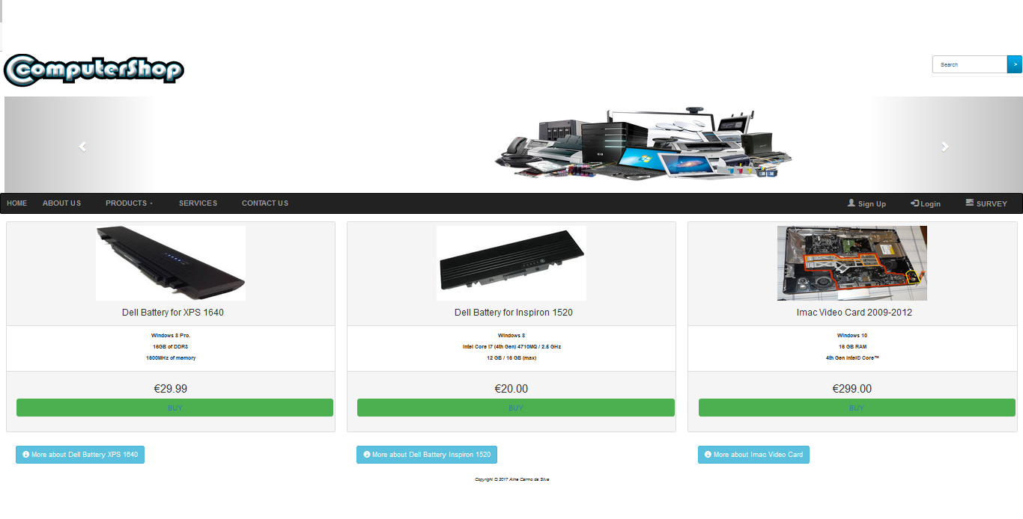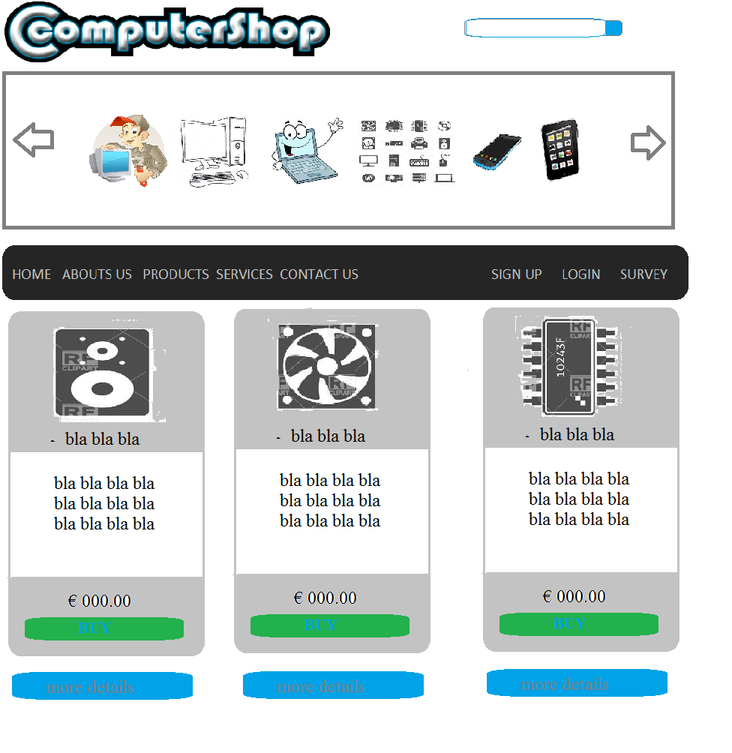

**Storboard: Services Actual Website: Services**

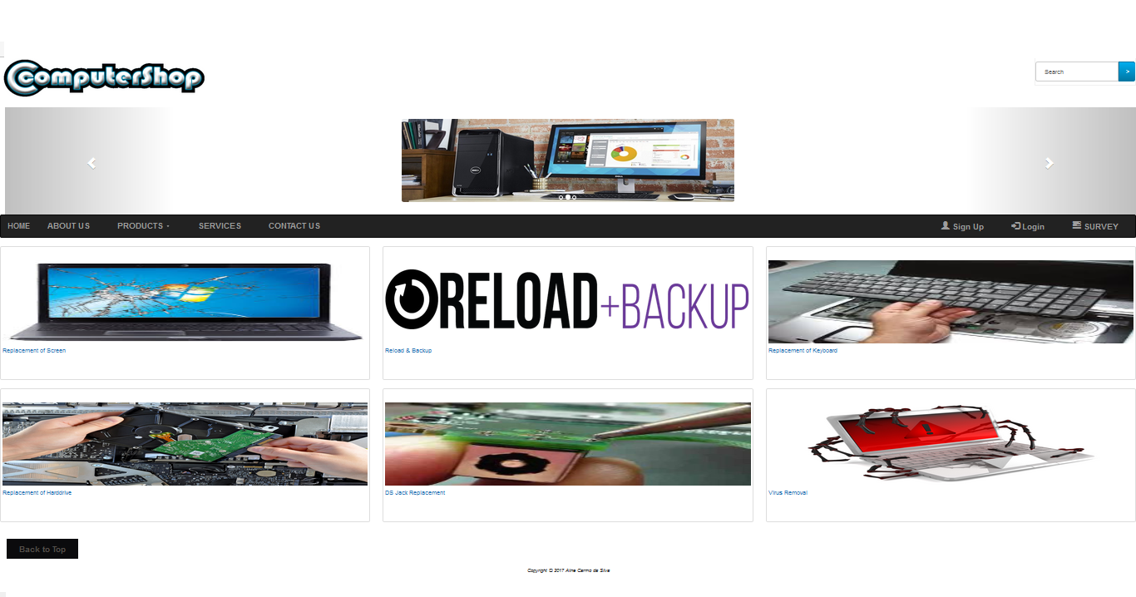

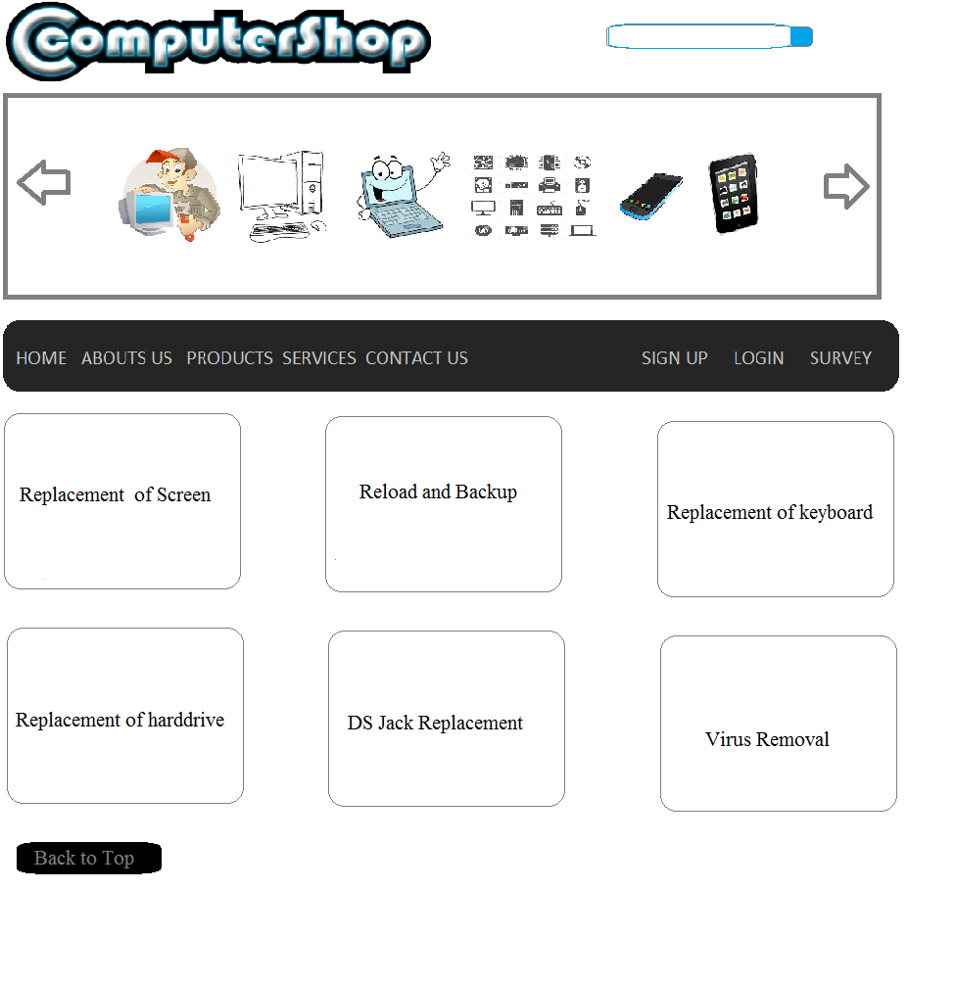

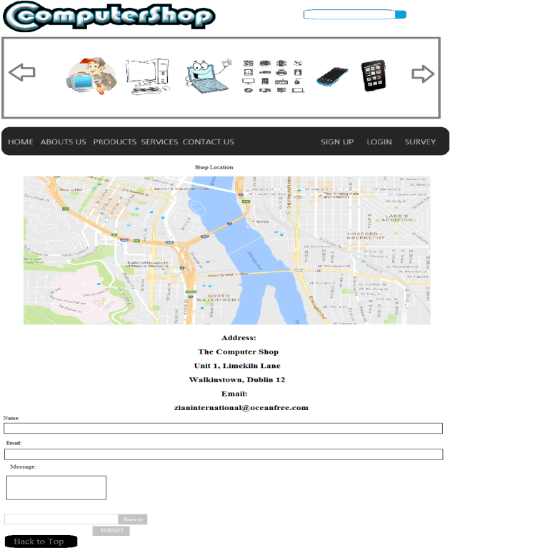**Storyboard: Contact us Actual Website: Contact us**

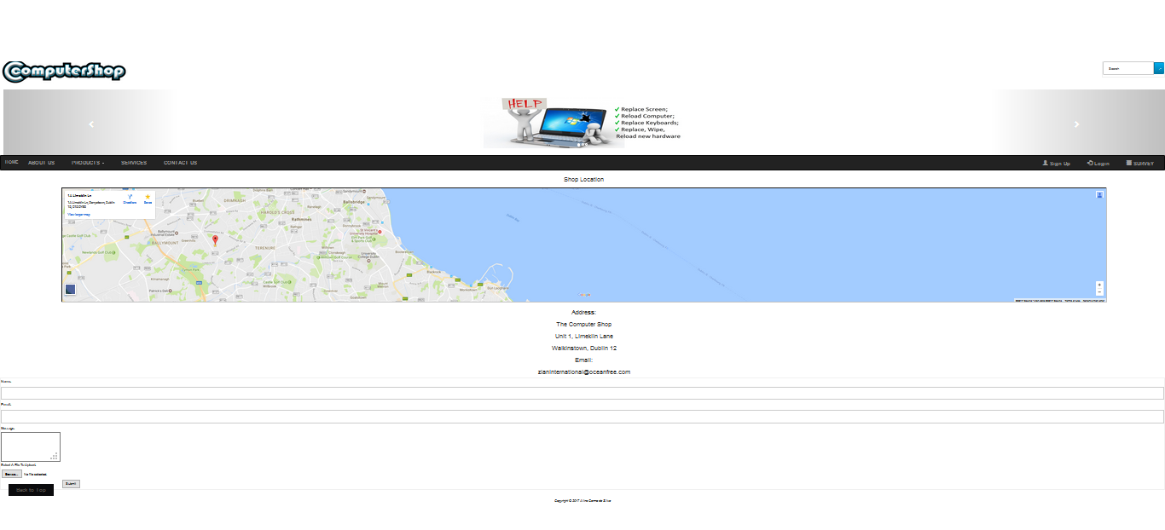

**Storyboard Sing up Actual Website: Sign up**

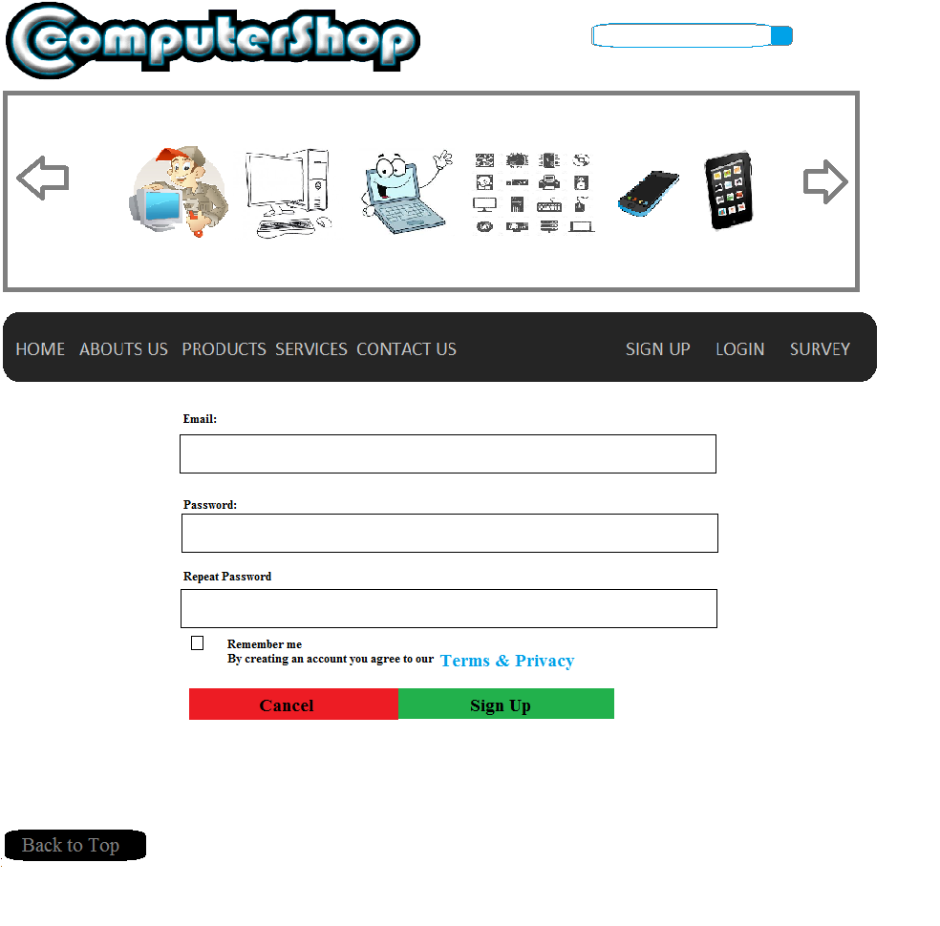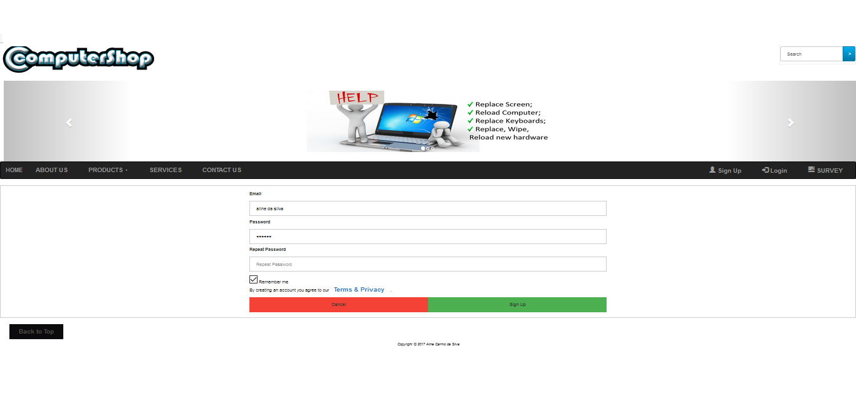

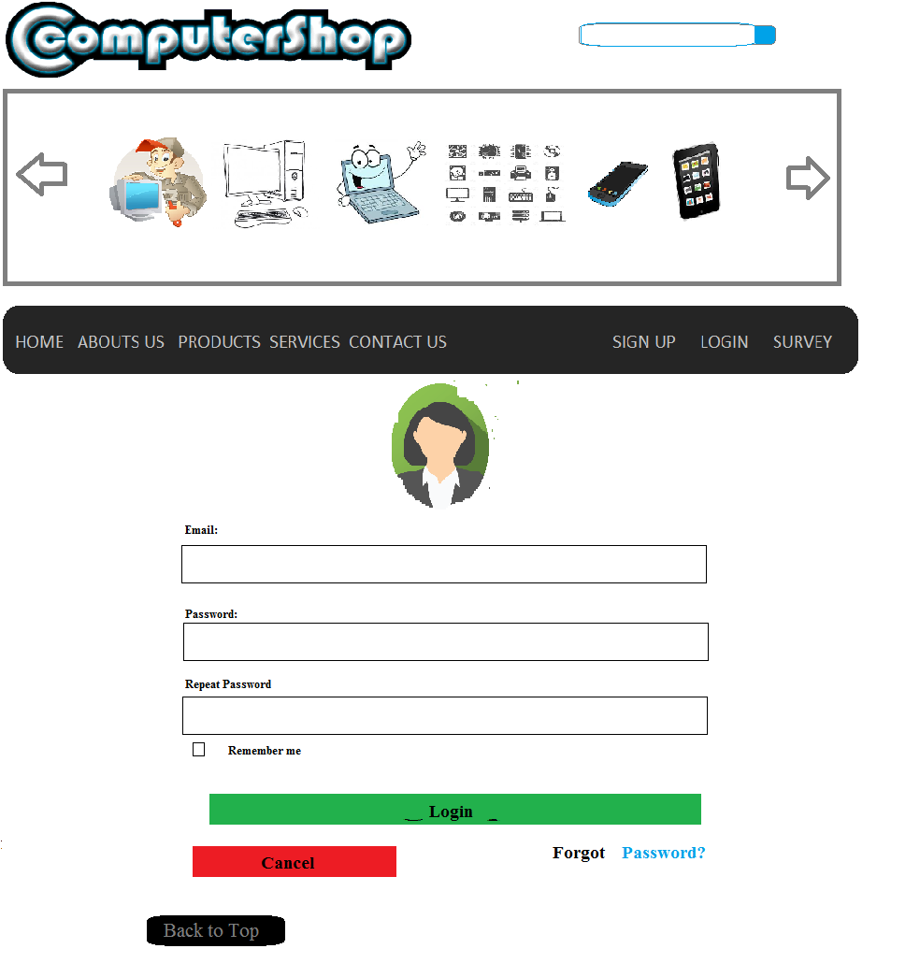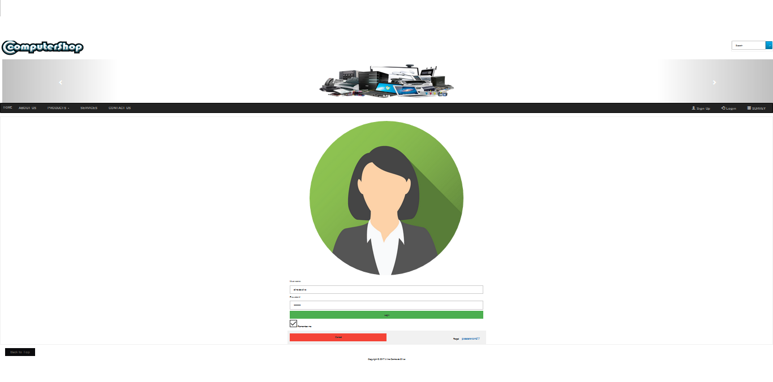**Storyboard: Login Actual Website: Login**

**Storyboard: Survey Actual Website: Survey**

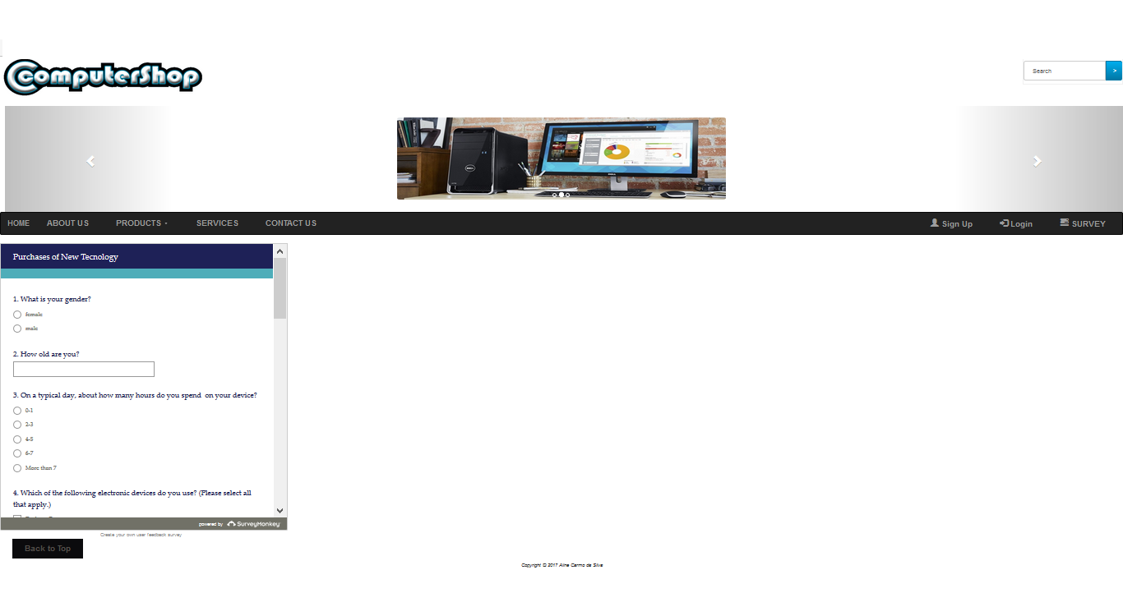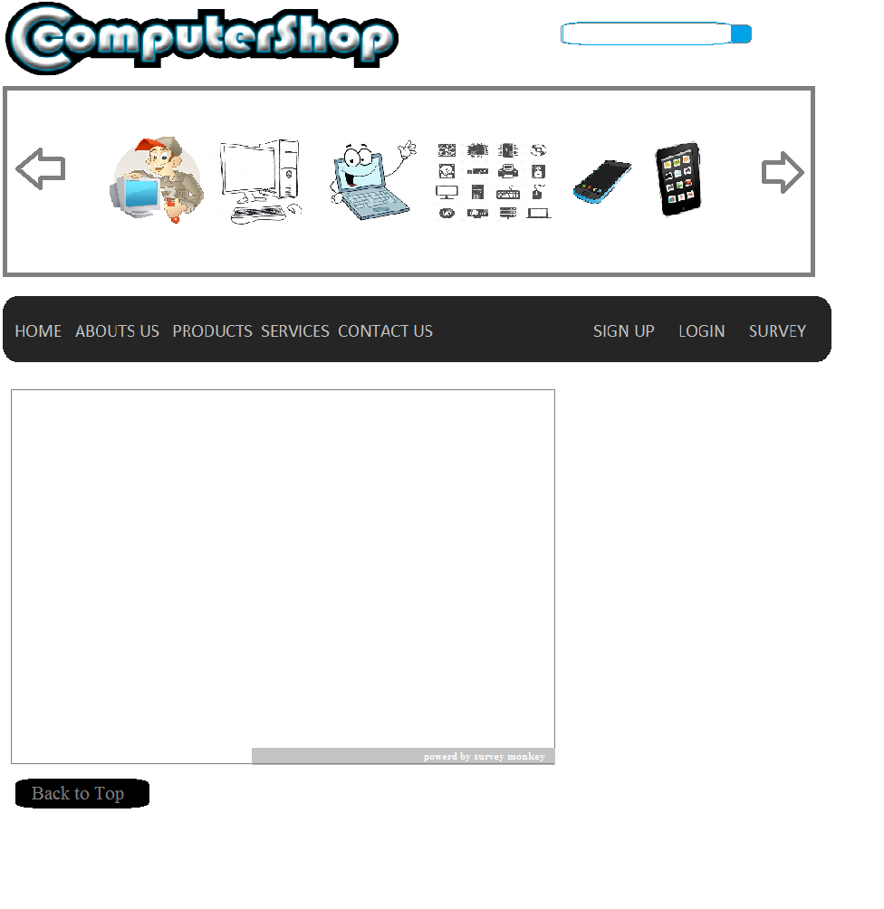

**Storyboard: product Actual Website: product**

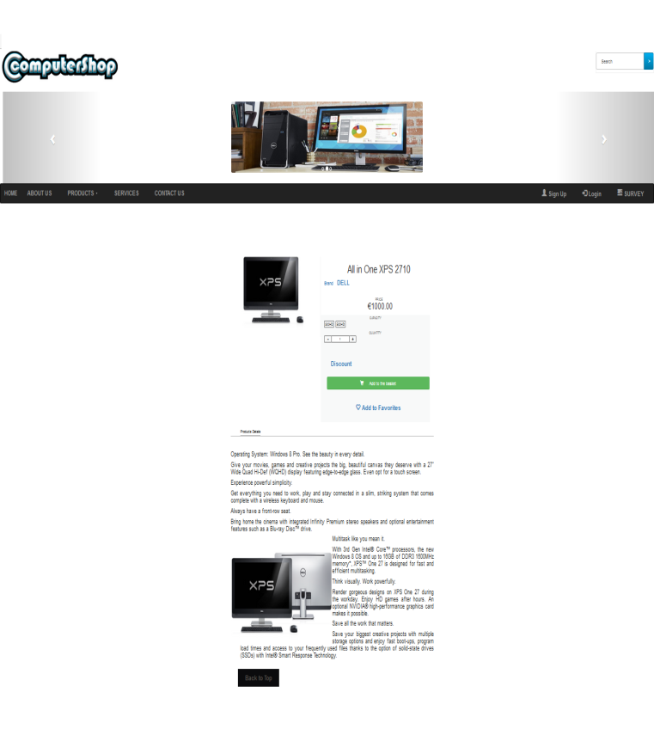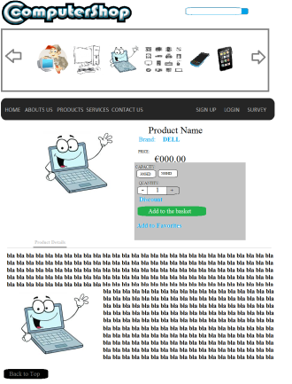

**Storyboard: address form Actual Website: address form**

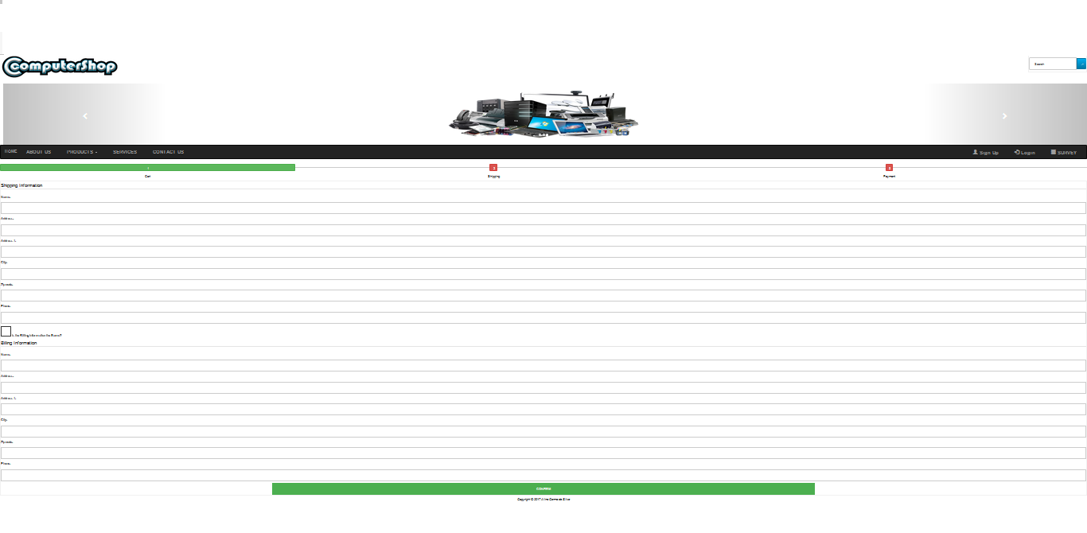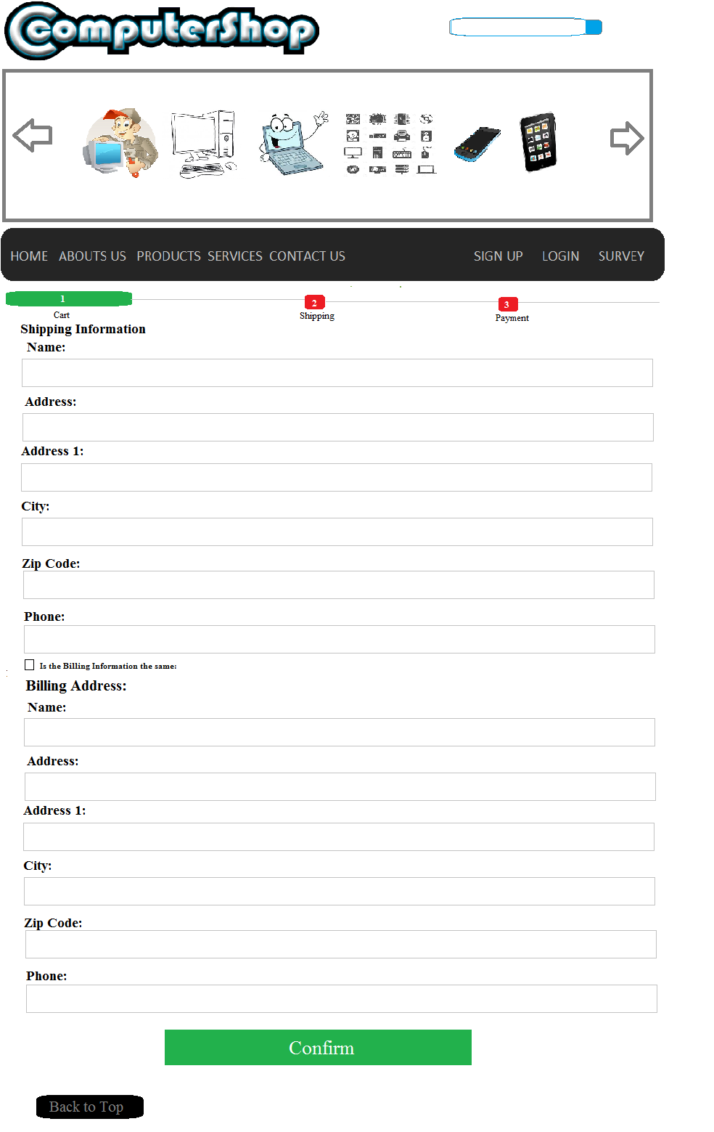

**Storyboard: payment form Actual Website: payment form**

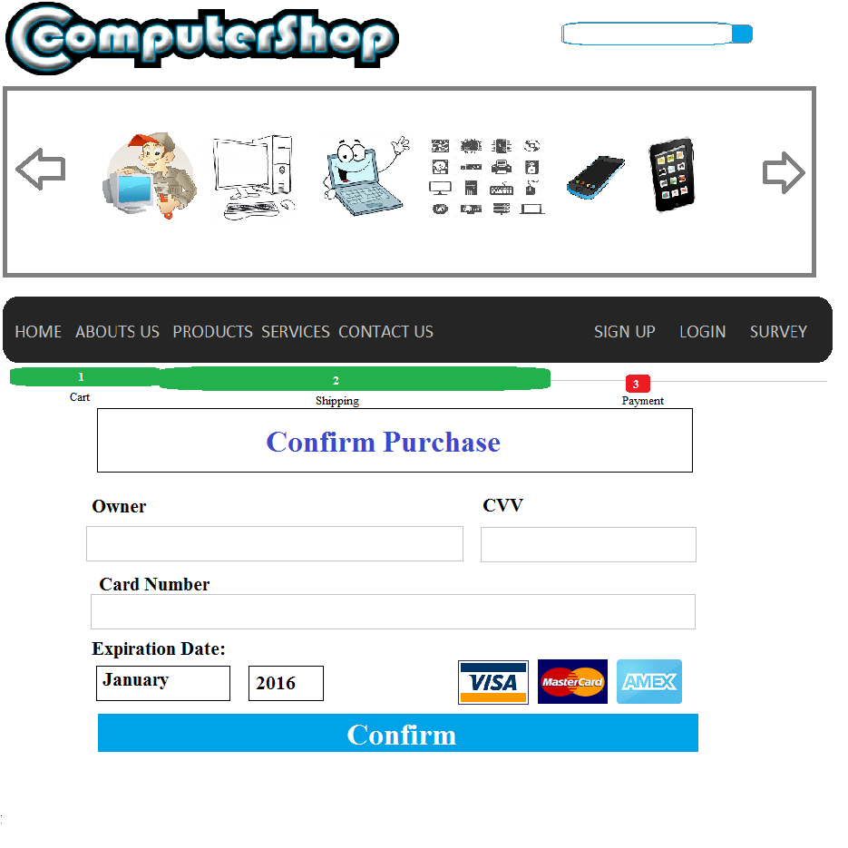

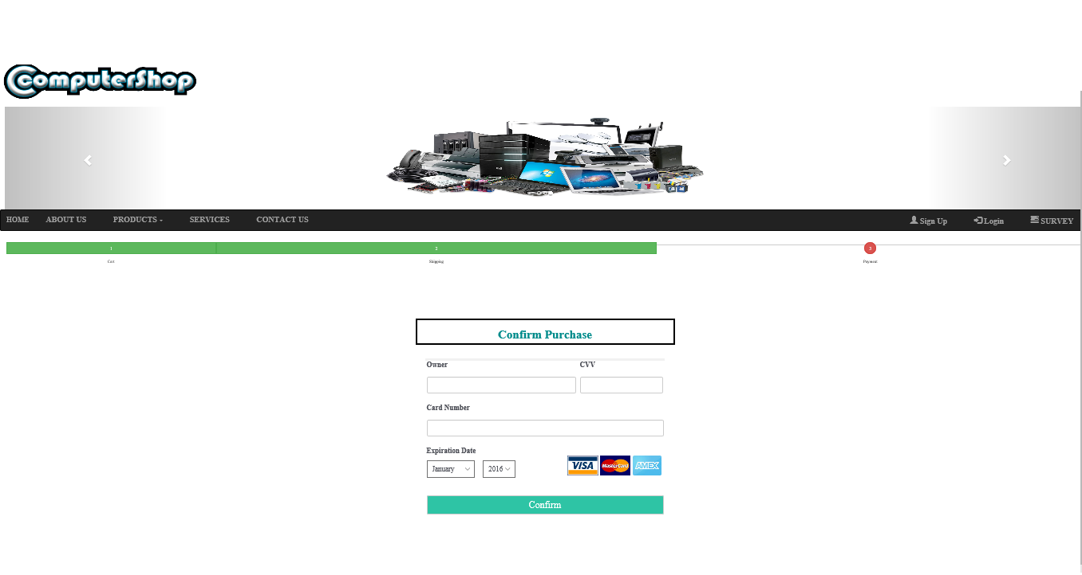

**Storyboard: thank you purchase Actual Website: thank you purchase**

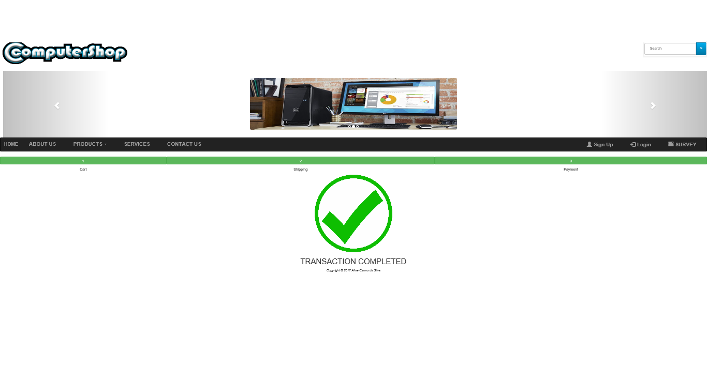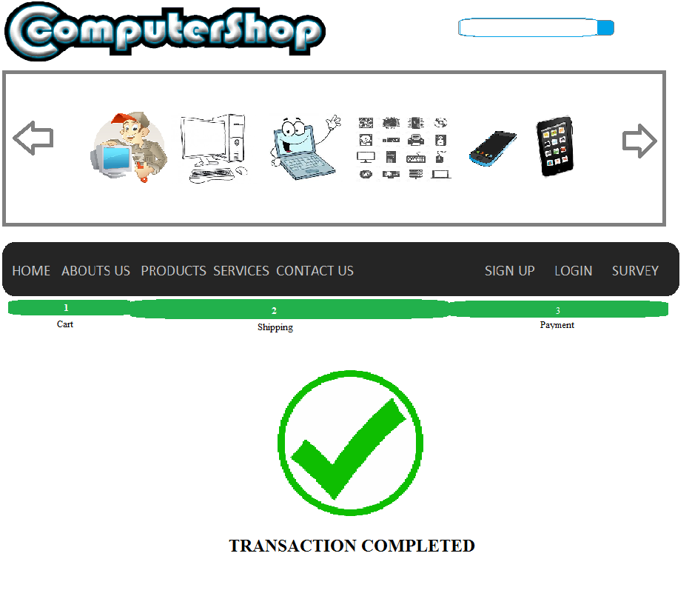

### Site Testing (errors, browser issues, cross platform).

### Usability testing (Accessibility, Navigation, Readability).



**Review website after testing and update the prototype**

